Name

Mathematics Advanced Year 12
Transformations of Trigonometric Functions

Book 1 |  | Version: 260409  Feedback:  https://MrDingMaths.com
Contents
Syllabus Content 2
Transformations and Properties of Waves 3
Combined Transformations 15
Solving Trigonometric Equations Algebraically & Graphically 23
Exam Questions 28

Syllabus Content
MAV-12-02 models, analyses and solves practical problems involving functions and their transformations
Transformations of trigonometric functions
- Use graphing applications to explore reflections, translations and dilations of, and confirm that the principles of transformations hold for, the trigonometric functions $f\left(x\right)=\sin{x}$, $f\left(x\right)=\cos{x}$ and $f(x)=\tan{x}$
- Apply the principles of transformations to graph transformations of the trigonometric functions $f\left(x\right)=\sin{x}$, $f\left(x\right)=\cos{x}$ and $f(x)=\tan{x}$, describe which transformations have been applied to $y=f(x)$ and determine the domain, range, horizontal translation, vertical translation, dilation factor, period and amplitude when applicable
- Solve equations and graphical problems involving transformations of the trigonometric functions $f\left(x\right)=\sin{x}$, $f\left(x\right)=\cos{x}$ or $f(x)=\tan{x}$, using graphing applications or otherwise, within a specified domain

Transformations and Properties of Waves

- Properties of Waves
In maths, we describe waves using the terms:
- Mean position
- Amplitude
- Period
- Phase
Note that $y=\sin{x}$ and $y=\cos{x}$ are waves, but $y=\tan{x}$ is not.
$y=\tan{x}$ only has period and phase.

- Interpret mean position
The mean position is the average $y$-value of the wave.
$y=\tan{x}$ does not have mean position as the graph is not continuous throughout its domain.
Mean position: $y=$ …… | 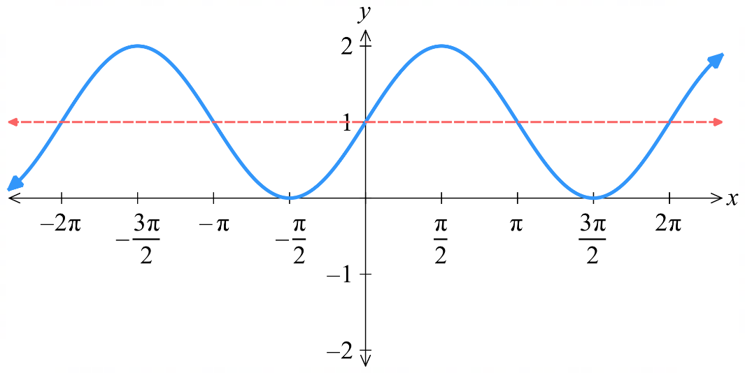  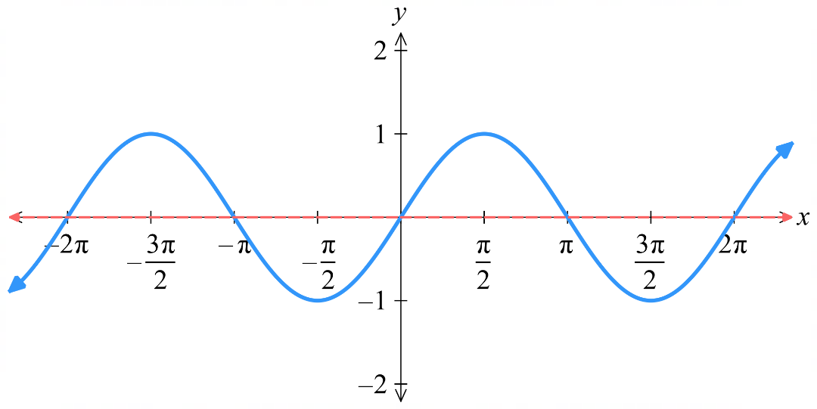  Mean position: $y=$ ……
Mean position: $y=$ …… | 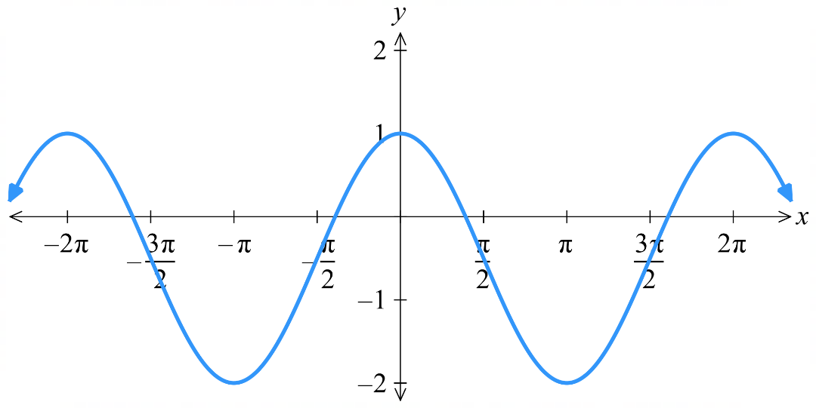  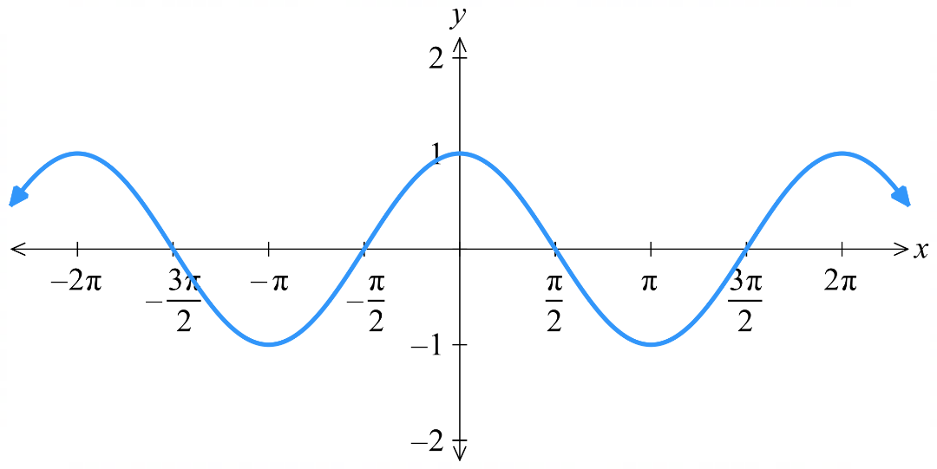  Mean position: $y=$ ……
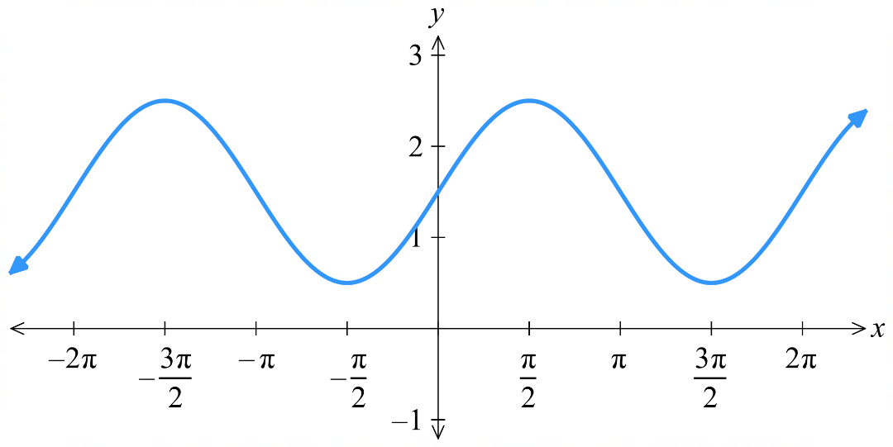  Mean position: $y=$ …… | 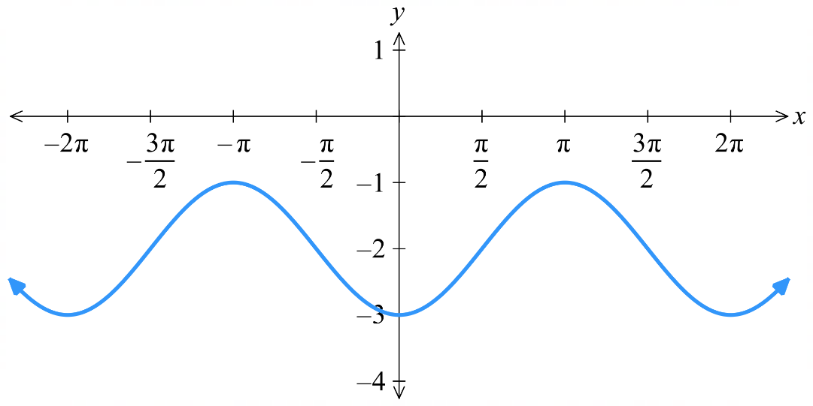  Mean position: $y=$ ……

- Interpret amplitude
The amplitude is the distance from the mean position to the maximum value.
$y=\tan{x}$ does not have amplitude as it does not have mean position.
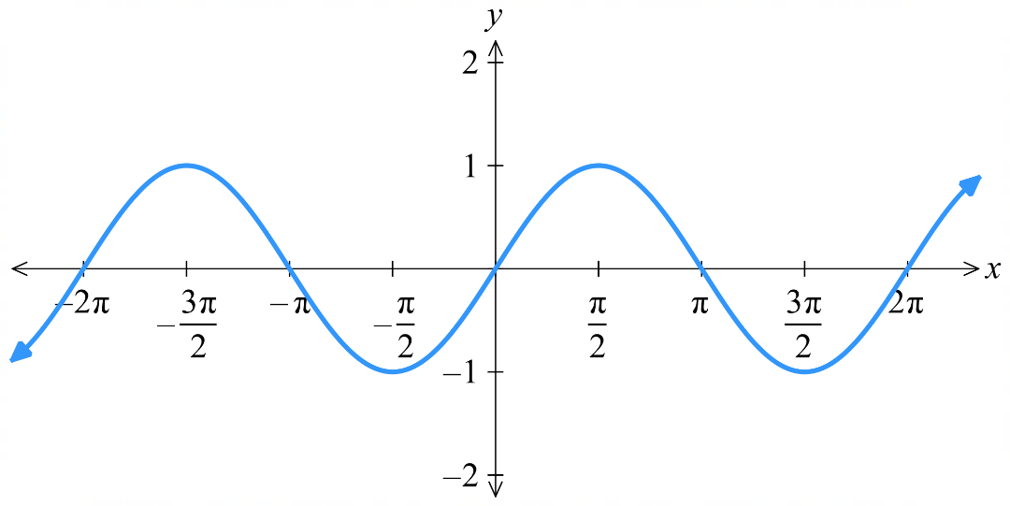  Amplitude: …… | 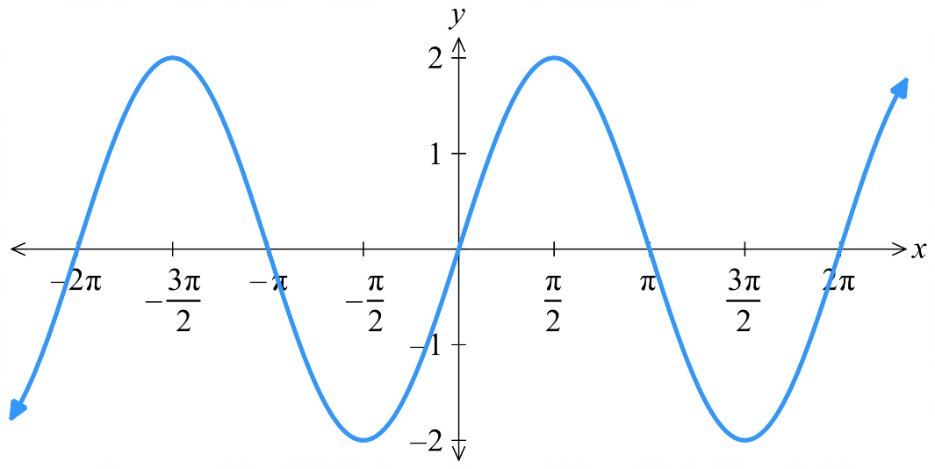  Amplitude: ……
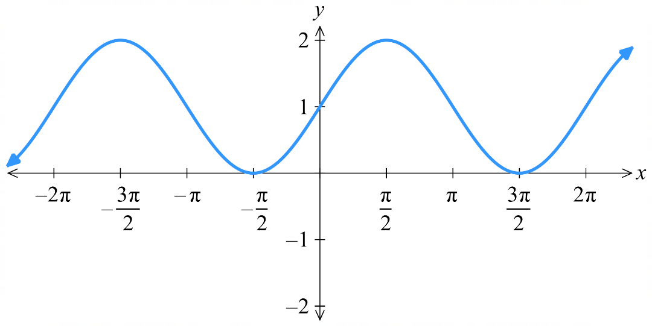  Amplitude: …… | 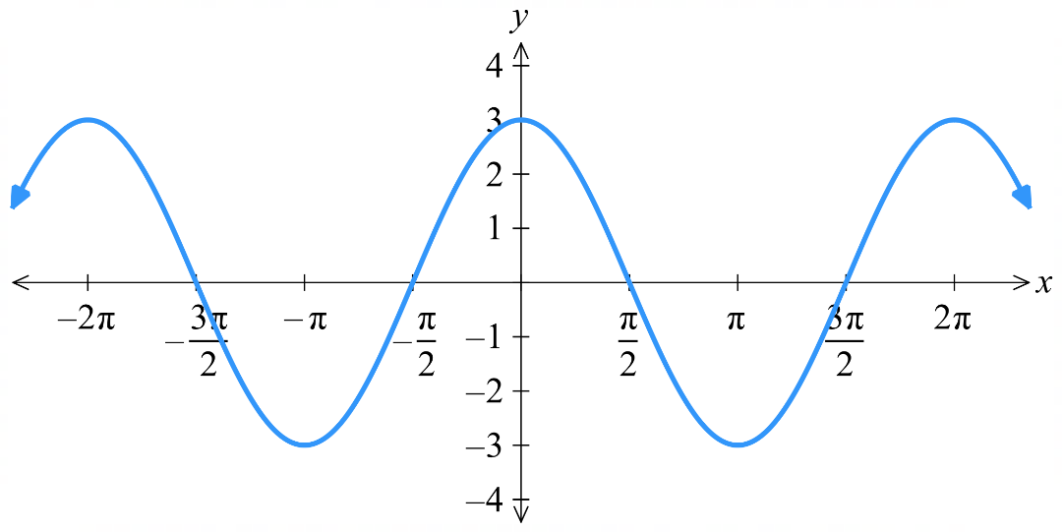  Amplitude: ……
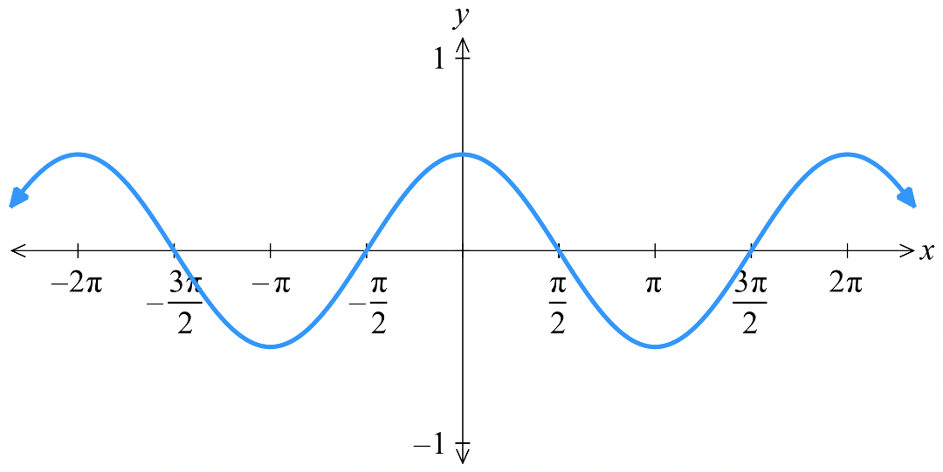  Amplitude: …… | 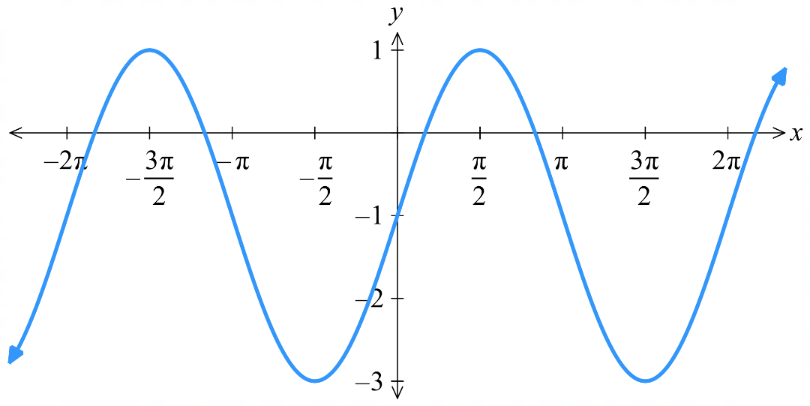  Amplitude: ……
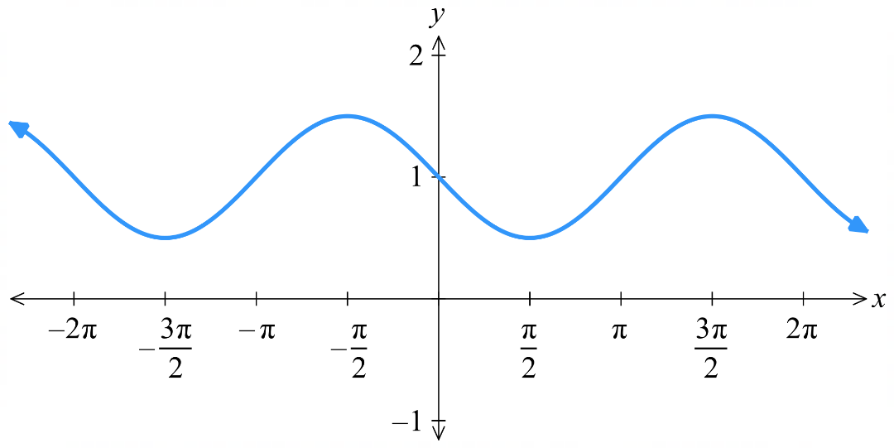  Amplitude: …… | 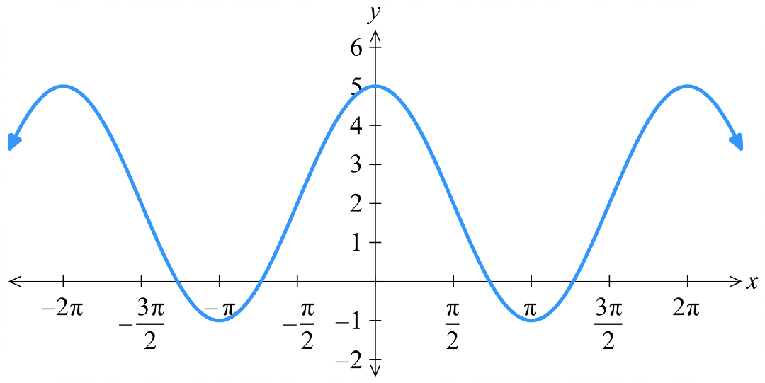  Amplitude: ……

- Interpret period
The period is the length of one complete cycle before the pattern repeats.
Period: …… | Period: ……
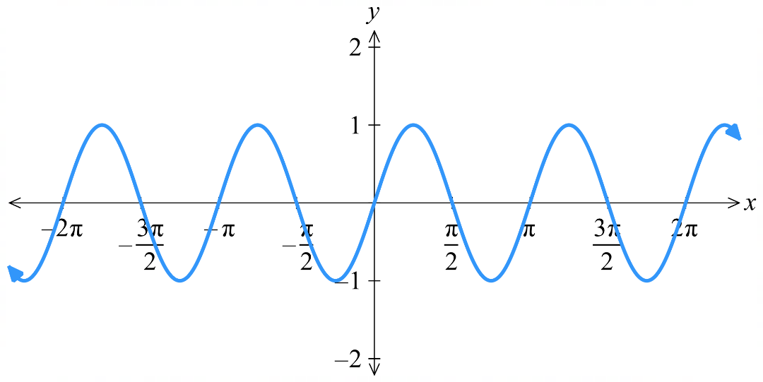  Period: …… | 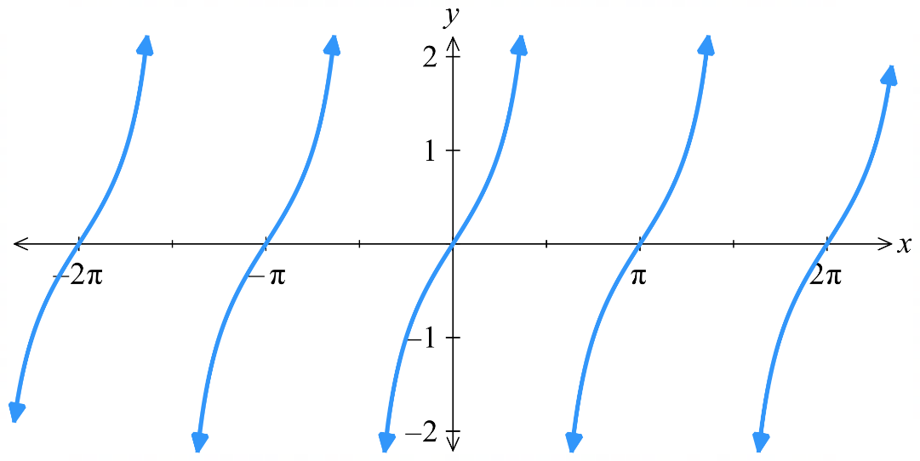  Period: ……
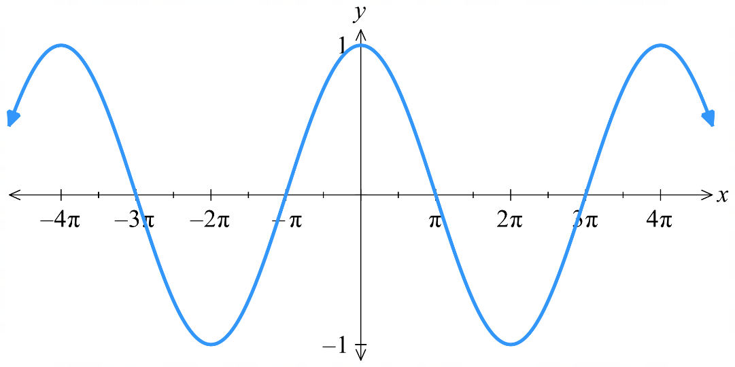  Period: …… | 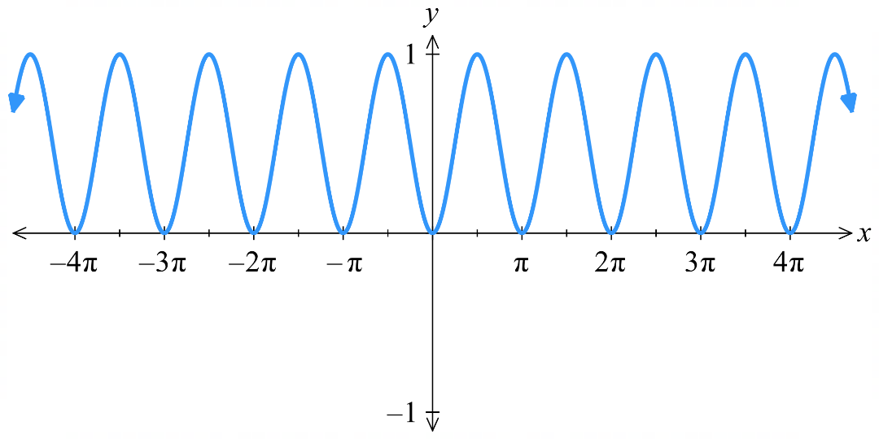  Period: ……
Period: …… | Period: ……

- Interpret phase
The phase is the horizontal shift of the wave from its original position.
A positive phase is a shift to the left. A negative phase is a shift to the right.
The phase is ambiguous without the equation. For now, use given arrow to determine phase.
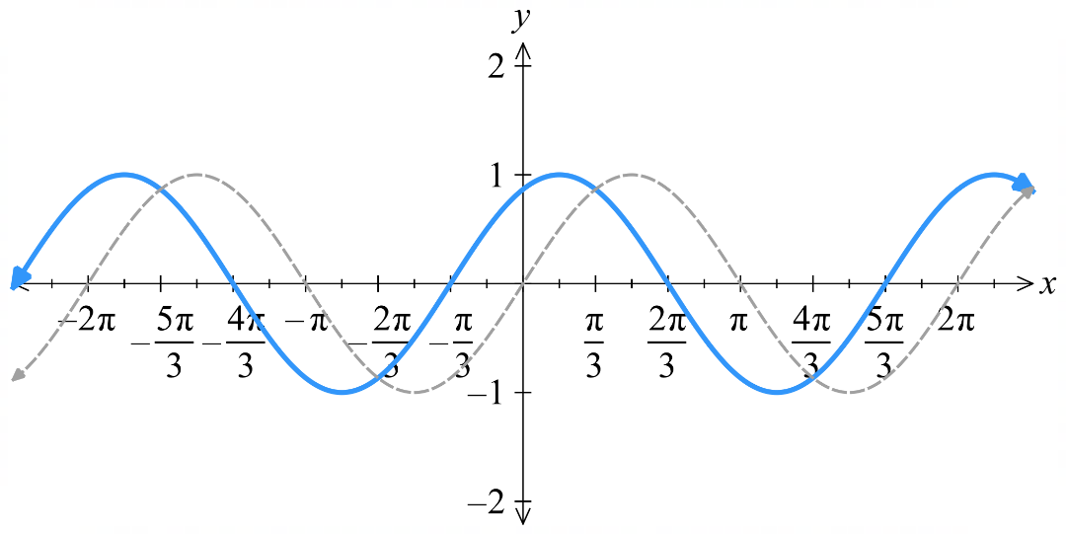  Phase: …… | 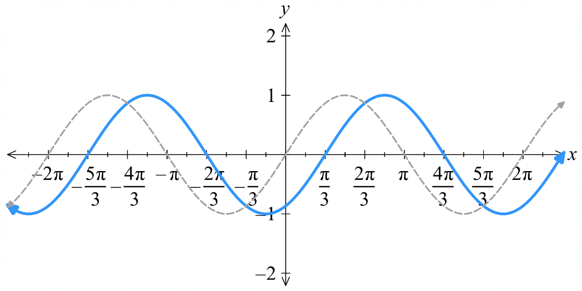  Phase: ……
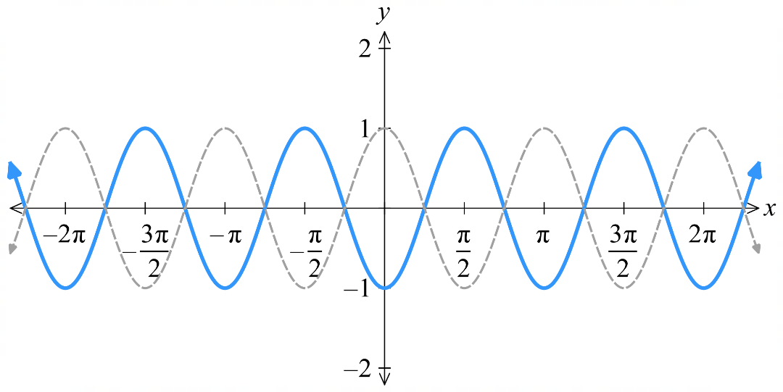  Phase: …… | Phase: ……
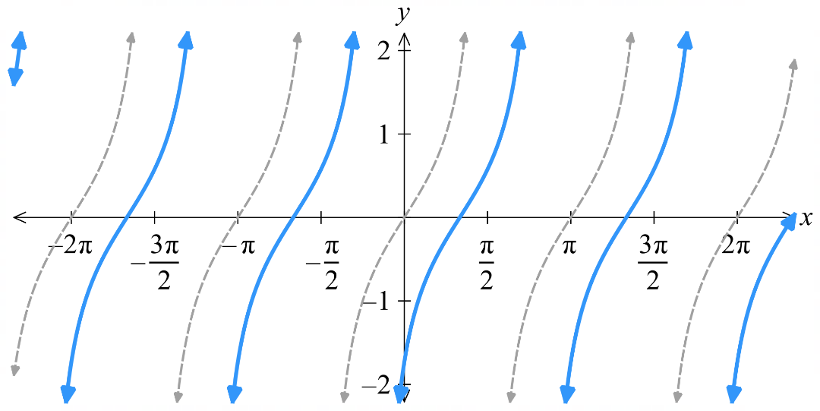  Phase: …… | 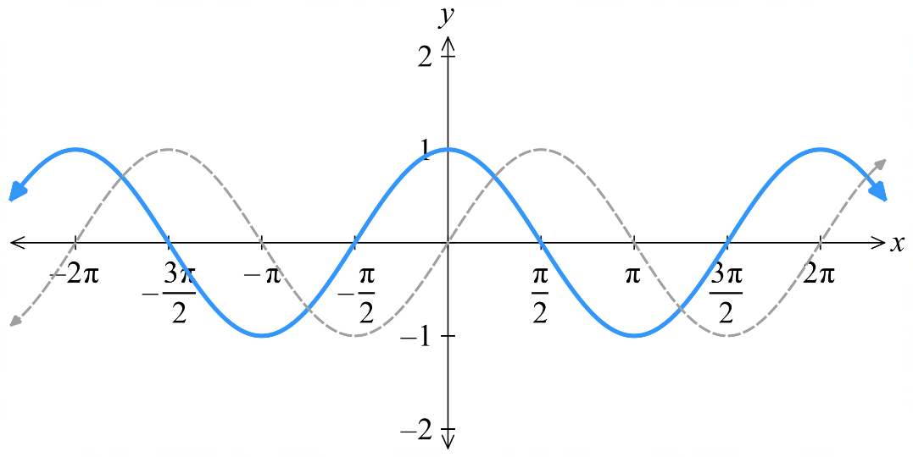  Phase: ……

- Interpret Transformations and Properties of Waves
Mean Position is Vertical Translation
The mean position of $f\left(x\right)=\sin{x}$and $f\left(x\right)=\cos{x}$ is 0.
$$y=\sin\left(x\right)+1$$  Mean position 1  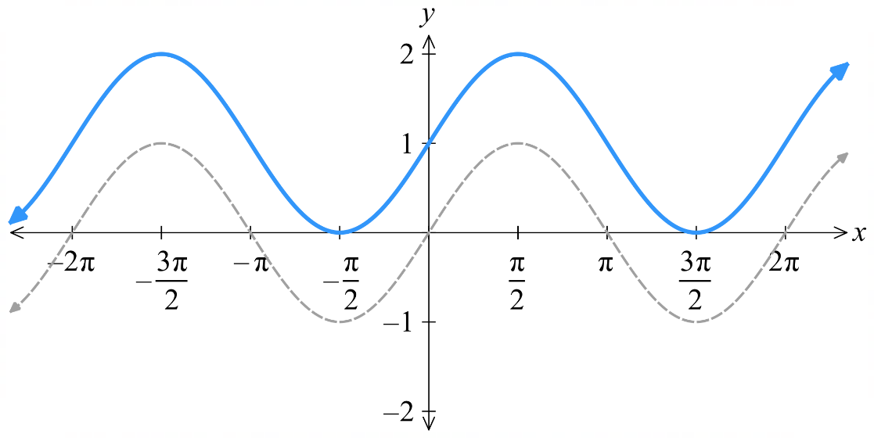  Vertical translation by $+1$ causes  mean position to shift up by 1 | $$y=\sin\left(x\right)-\frac{1}{2}$$  Mean position $-\frac{1}{2}$  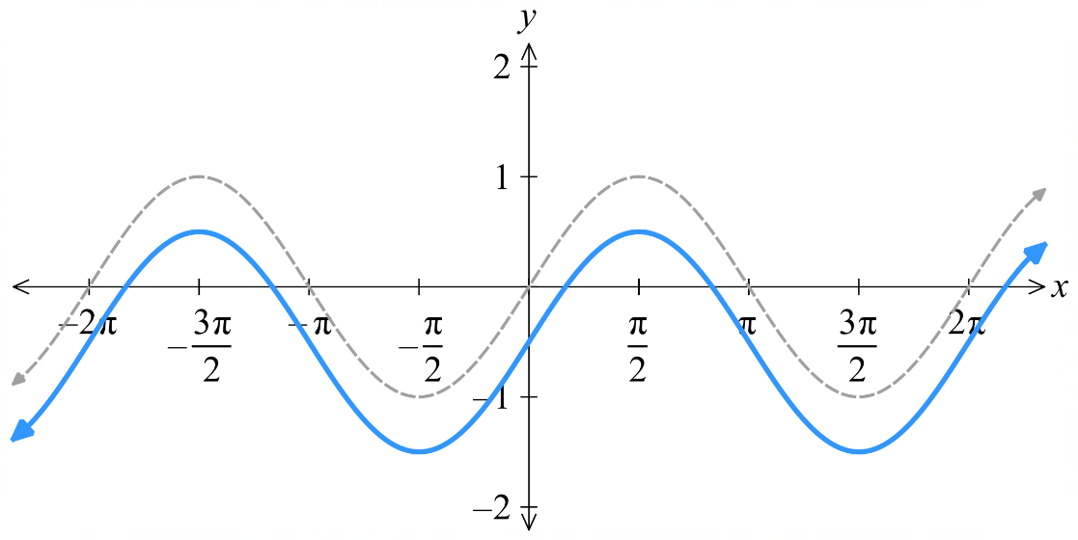  Vertical translation by $-\frac{1}{2}$ causes  mean positions to shift down by $\frac{1}{2}$
The vertical translation determines the mean position.
$$f\left(x\right)=\sin\left(x\right)+c$$
$$f\left(x\right)=\cos\left(x\right)+c$$

For $y=\sin{(x)}+3$: The vertical translation is ……… and the mean position is ………
For $y=\cos{(x)}+3$: The vertical translation is ……… and the mean position is ………
For $y=\cos{(x)}-3$: The vertical translation is ……… and the mean position is ………
For $y=\cos{(x)}-12$: The vertical translation is ……… and the mean position is ………
For $y=\sin{(x)}+\frac{3}{2}$: The vertical translation is ……… and the mean position is ………

We can vertically translate $f\left(x\right)=\tan{x}+c,$ but we don’t call it the mean position.

Amplitude and Vertical Dilation
The amplitude of $f\left(x\right)=\sin{x},$and $f\left(x\right)=\cos{x}$ is 1.
$$y=2\sin\left(x\right)$$  amplitude 2  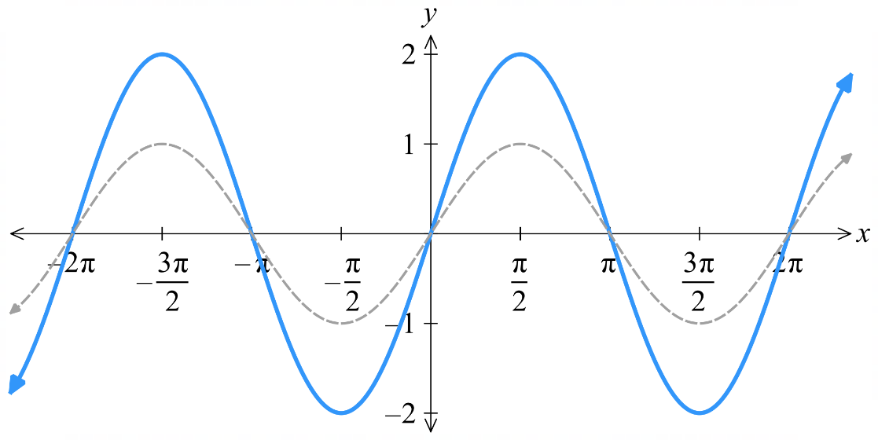  Vertical dilation by factor 2 causes  amplitude to be multiplied by 2 | $$y=\frac{1}{3}\sin\left(x\right)$$  amplitude $\frac{1}{3}$  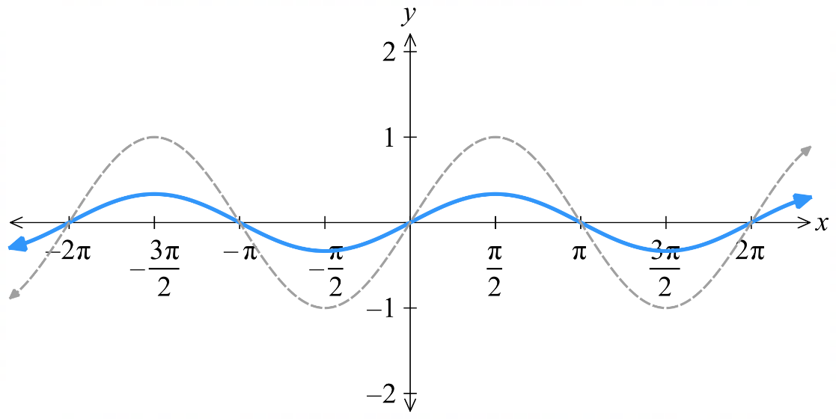  Vertical dilation by factor $\frac{1}{3}$ causes  amplitude to be multiplied by $\frac{1}{3}$
The vertical dilation factor determines the amplitude.
$$f\left(x\right)=k\sin\left(x\right)$$
$$f\left(x\right)=k\cos\left(x\right)$$

For $y=3\sin{(x)}$: The vertical dilation factor is ……… and the amplitude is ………
For $y=5\sin{(x)}$: The vertical dilation factor is ……… and the amplitude is ………
For $y=\frac{1}{2}\sin{(x)}$: The vertical dilation factor is ……… and the amplitude is ………
For $y=\frac{\sin\left(x\right)}{2}$: The vertical dilation factor is ……… and the amplitude is ………
For $y=\frac{\sin\left(x\right)}{4}$: The vertical dilation factor is ……… and the amplitude is ………
For $y=\frac{3sin\left(x\right)}{4}$: The vertical dilation factor is ……… and the amplitude is ………

We can vertically dilate $f\left(x\right)=k\tan\left(x\right),$ but we don’t call it the amplitude.

Period and Horizontal Dilation
The period of $f\left(x\right)=\sin{x},$and $f\left(x\right)=\cos{x}$ is $2π$.
The period of $f\left(x\right)=\tan{(x)}$ is $π$.
$$y=\sin\left(3x\right)$$  period: $\frac{2π}{3}$  Horizontal dilation by factor $\frac{1}{3}$ causes  period to be $\frac{1}{3}$ of original. | $$y=\sin\left(\frac{x}{2}\right)$$  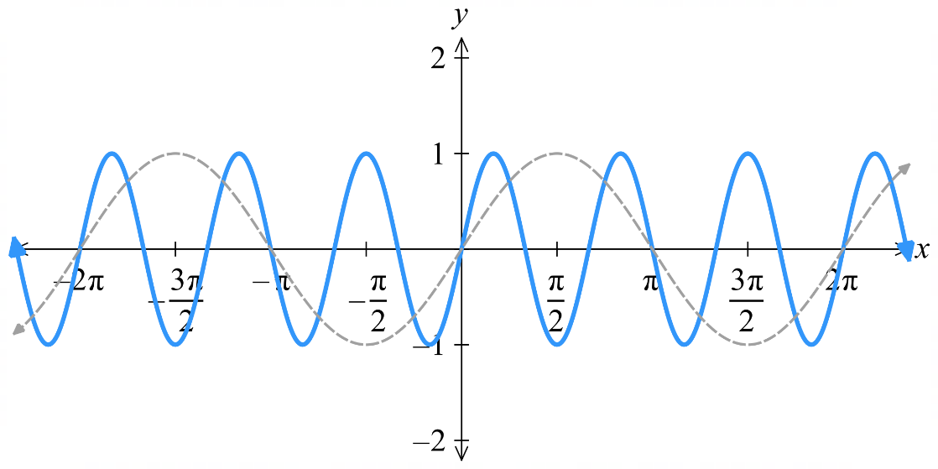  period: $4π$  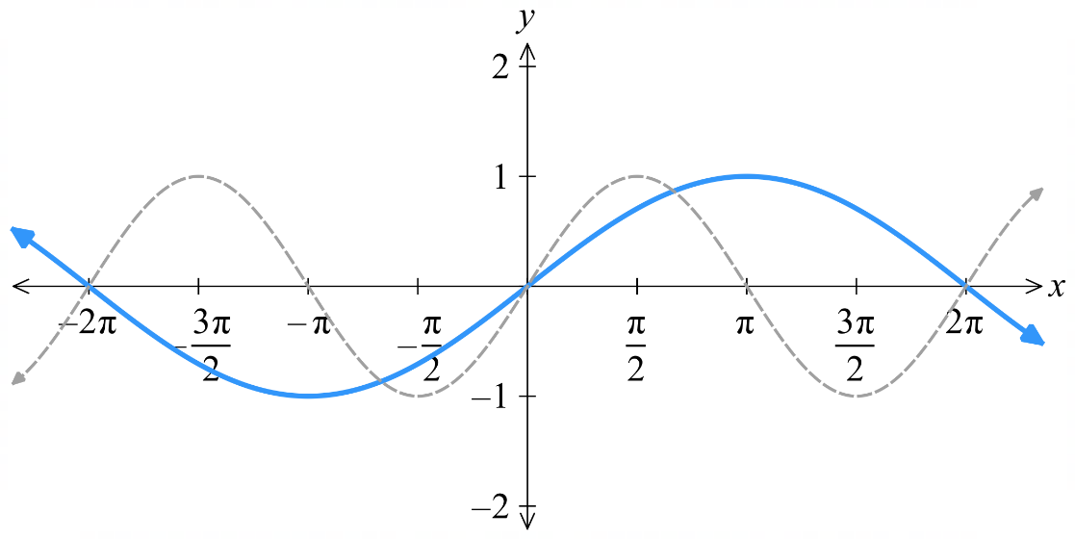  Horizontal dilation by factor $2$ causes  period to be 2$×$ original.
The horizontal dilation factor determines the period.
$$f\left(x\right)=\sin\left(ax\right)$$
$$f\left(x\right)=\cos\left(ax\right)$$
$$f\left(x\right)=\tan\left(ax\right)$$

For $f\left(x\right)=\sin\left(2x\right)$: the horizontal dilation factor is ………… and the period is ……………
For $f\left(x\right)=\sin\left(3x\right)$: the horizontal dilation factor is ………… and the period is ……………
For $f\left(x\right)=\sin\left(\frac{x}{3}\right)$: the horizontal dilation factor is ………… and the period is ……………
For $f\left(x\right)=\sin\left(\frac{2x}{3}\right)$: the horizontal dilation factor is ………… and the period is ……………
For $f\left(x\right)=\tan\left(3x\right)$: the horizontal dilation factor is ………… and the period is ……………

- For $f\left(x\right)=\sin\left(ax\right)$, we call this a dilation factor of $\frac{1}{a},$ since the period is divided by $a$.
- For $f\left(x\right)=\sin\left(\frac{x}{a}\right)$, we call this a dilation factor of $a,$ since the period is multiplied by $a.$

Phase and Horizontal Translation
The phase of $f\left(x\right)=\sin{x},$and $f\left(x\right)=\cos{x}$ and $f\left(x\right)=\tan{(x)}$ is $0$.
$$y=\sin\left(x+\frac{π}{6}\right)$$  phase: $\frac{π}{6}$  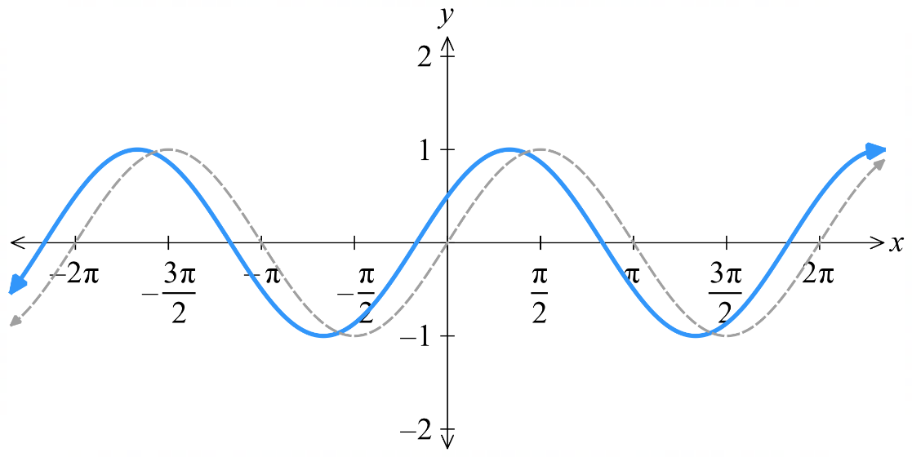  Horizontal translation $\frac{π}{6}$ left causes  phase to be $\frac{π}{6}$ | $$y=\sin\left(x-\frac{π}{6}\right)$$  phase: $-\frac{π}{6}$  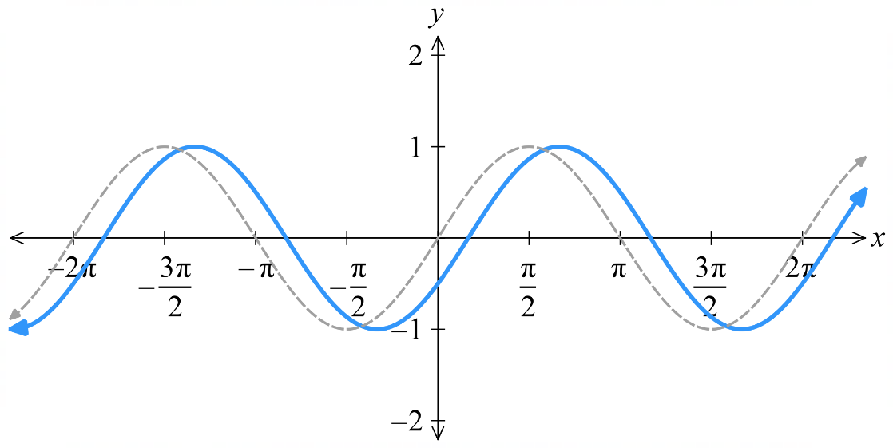  Horizontal translation $\frac{π}{6}$ right causes  phase to be $-\frac{π}{6}$
The horizontal translation determines the phase.
$$f\left(x\right)=\sin{(x-b)}$$
$$f\left(x\right)=\cos{(x-b)}$$
$$f\left(x\right)=\tan\left(x-b\right)$$

- For $f\left(x\right)=\sin\left(x+b\right)$, we call this a phase of $b,$ and a shift of $b$ to the left.
- For $f\left(x\right)=\sin\left(x-b\right)$, we call this a phase of $-b,$ and a shift of $b$ to the right.

For $f\left(x\right)=\sin\left(x-\frac{π}{3}\right)$: the phase is ……… and it is a shift of ……… to the …………
For $f\left(x\right)=\sin\left(x+\frac{π}{3}\right)$: the phase is ……… and it is a shift of ……… to the …………
For $f\left(x\right)=\sin\left(x+\frac{2π}{3}\right)$: the phase is ……… and it is a shift of ……… to the …………
For $f\left(x\right)=\sin\left(x-\frac{π}{4}\right)$: the phase is ……… and it is a shift of ……… to the …………

- Transformations and Properties of Waves
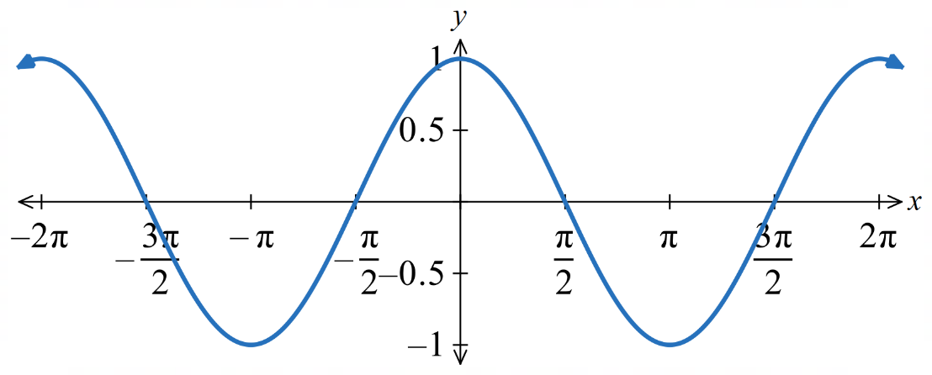
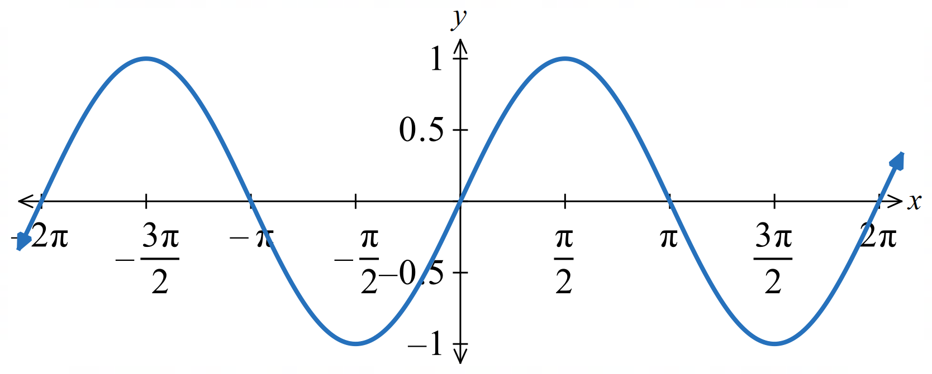
The original graphs:
$y=\sin{x}$ $y=\cos{x}$

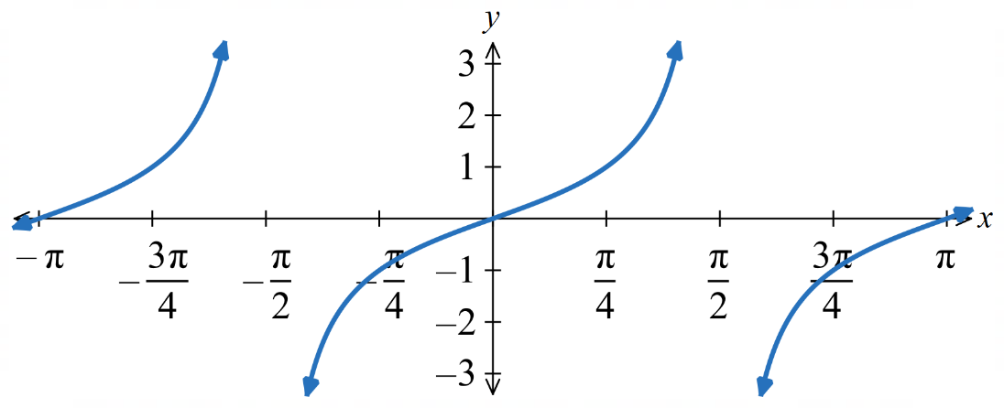
$$y=\tan{x}$$

Vertical translations and mean position
The mean position is the average $y$-value of the wave.
- $y=\sin{x}$ and $y=\cos{x}$ have mean position 0.
- $y=\sin{(x)}+c$and $y=\cos{(x)}+c$ have mean position $c$.
- $y=\tan{x}$ does not have a mean position.
- $y=\tan\left(x\right)+c$ shifts the graph vertically.

Vertical dilations and amplitude
- The amplitude of a wave is the distance from the mean position to the maximum value.
- $y=\sin{x}$ and $y=\cos{x}$ both have amplitude 1.
- $y=k\sin{x}$ and $y=k\cos{x}$ both have amplitude $k$.
- $y=\tan{x}$ does not have an amplitude.
- $y=k\tan{x}$ changes the steepness of the graph.

Horizontal dilations and period
The period of a wave function is the length of the smallest repeating unit.
- $y=\sin{x}$ and $y=\cos{x}$ both have period $2π$.
- $y=\sin\left(ax\right)$ and $y=\cos\left(ax\right)$ both have period $\frac{2π}{a}$.
- $y=\tan{x}$ has period $π$.
- $y=\tan\left(ax\right)$ has period $\frac{π}{a}$.

Horizontal translations and phase
The phase of a wave is the horizontal shift from the original position.
- $y=\sin{x}$, $y=\cos{x}$, $y=\tan{x}$ have phase 0.
- $y=\sin{(x-b)},$ $y=\cos{(x-b)},$ $y=\tan{(x-b)}$ have phase $-b$ and shift right by $b$ units.

Foundation
- Find the equation of the transformation of y = sin x if the transformed function has:
- amplitude 9  $$y=9\sin{x}$$ | - reflection across $x$-axis  $$y=-\sin{x}$$ | - Mean position $-4$  $$y=\sin{x}-4$$
- period $π$  $$y=\sin{2x}$$ | - a phase shift of π units to the right  $$y=\sin\left(x-π\right)$$

- Find the equation of the transformation of y = cos x if the transformed function has:
- amplitude 4  $$y=4\cos{x}$$ | - a phase of $\frac{π}{3}$ units  $$y=\cos\left(x+\frac{π}{3}\right)$$ | - Mean position 8  $$y=\cos{x}+8$$
- period $\frac{π}{2}$  $$y=\cos{4x}$$ | - a vertical dilation with scale factor 7  $$y=7\cos{x}$$

- Sketch the graph of each function in the domain $\left[0,2π\right]$.
- $y=5\sin{x}$  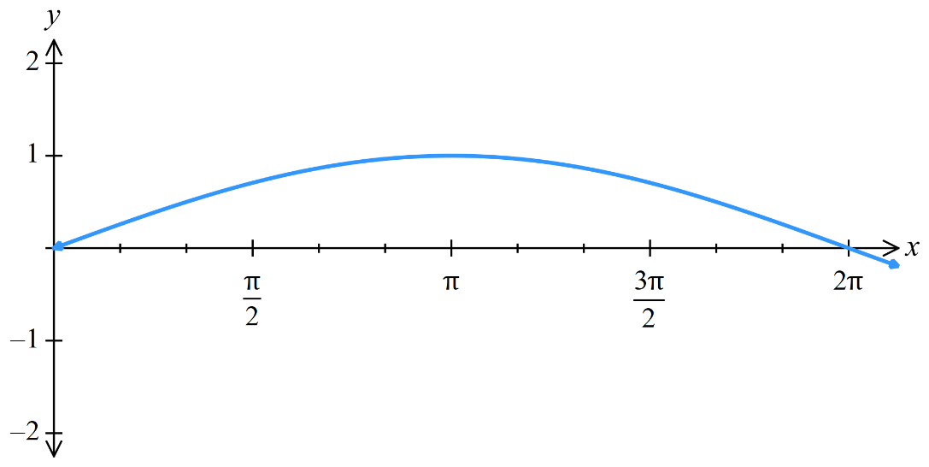  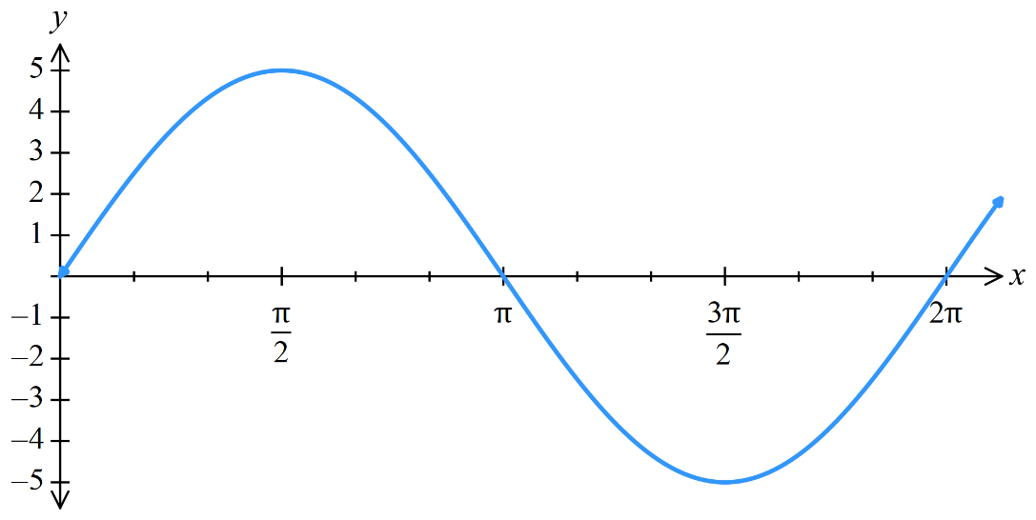  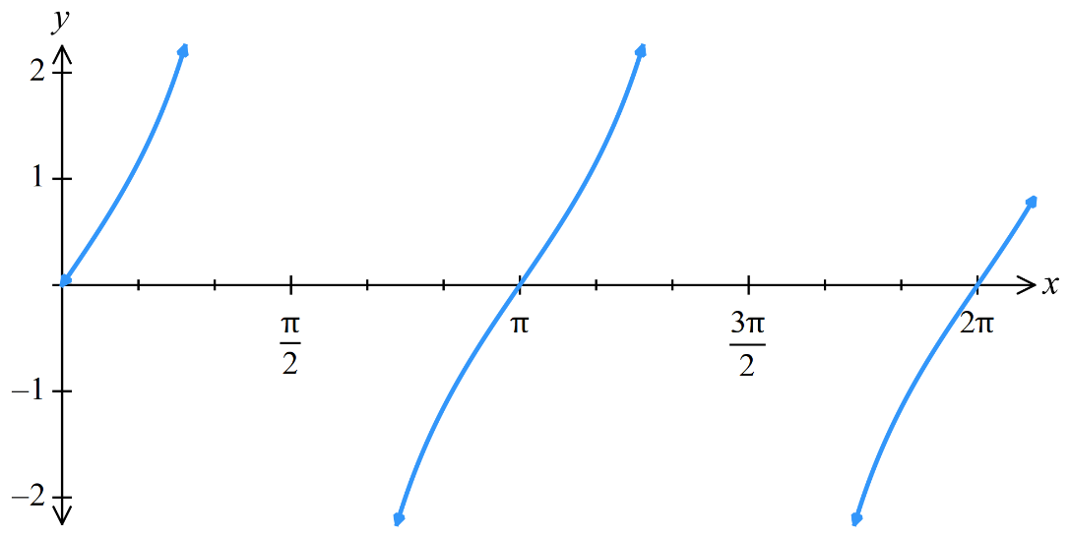  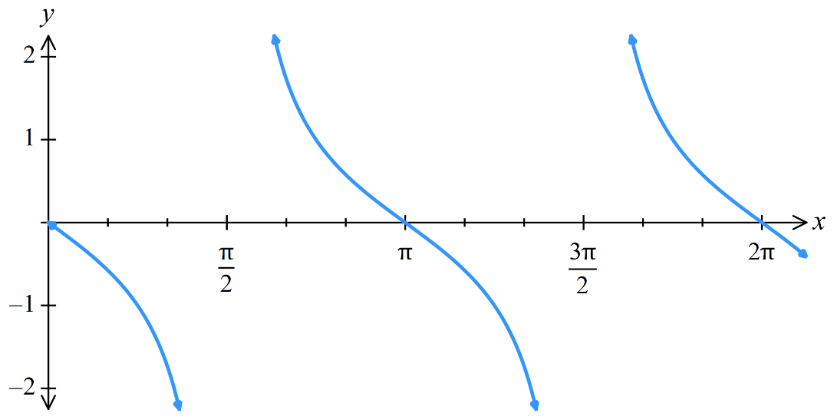  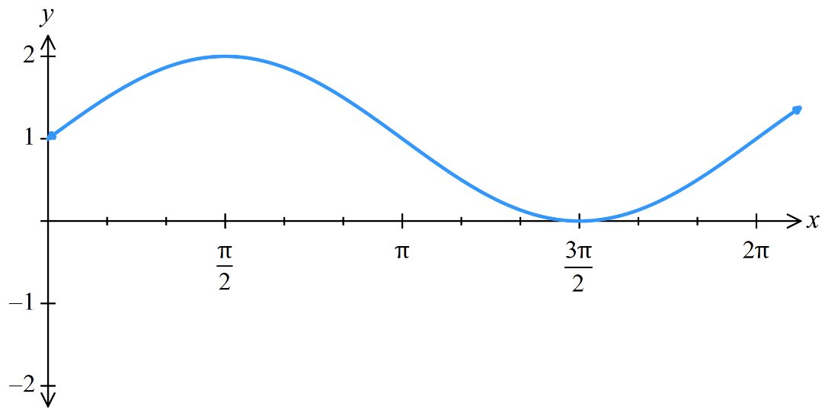  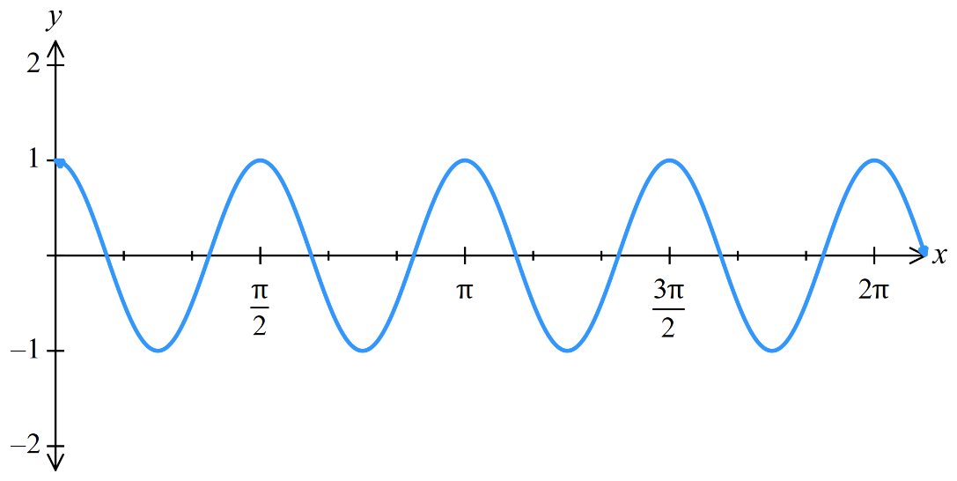  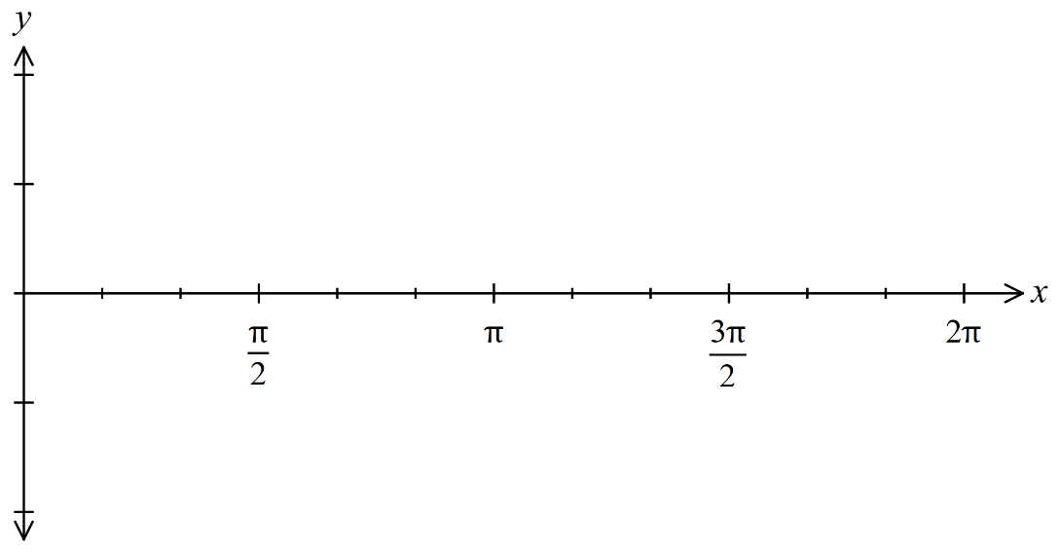 | - $y=2\tan{x}$
- $y=-\tan{x}$ | - $y=\sin{x}+1$
- $y=\cos{4x}$ | - $y=\sin\left(\frac{x}{2}\right)$
- $y=\tan{x}-2$ | - $y=\cos{x}-3$  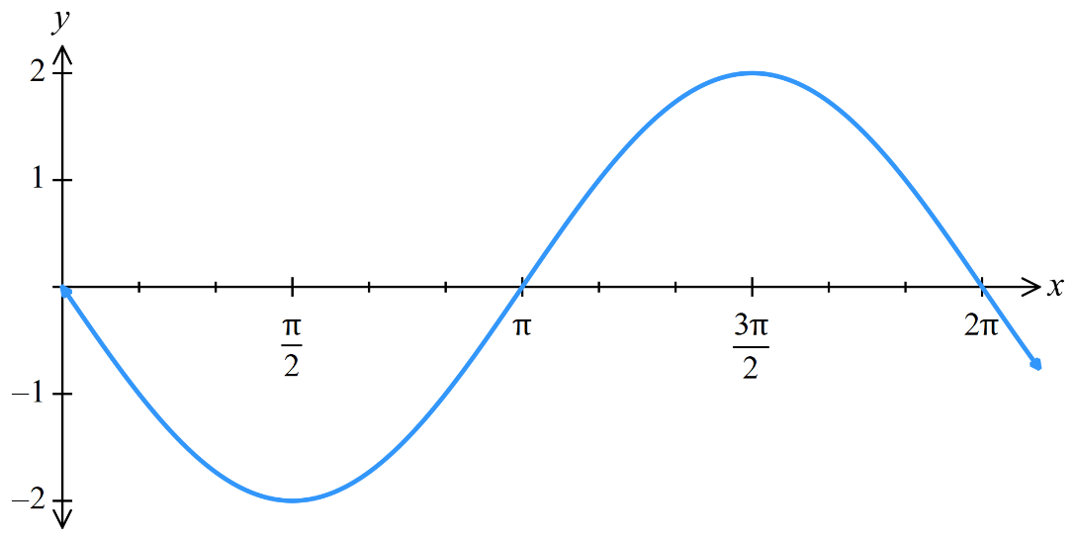  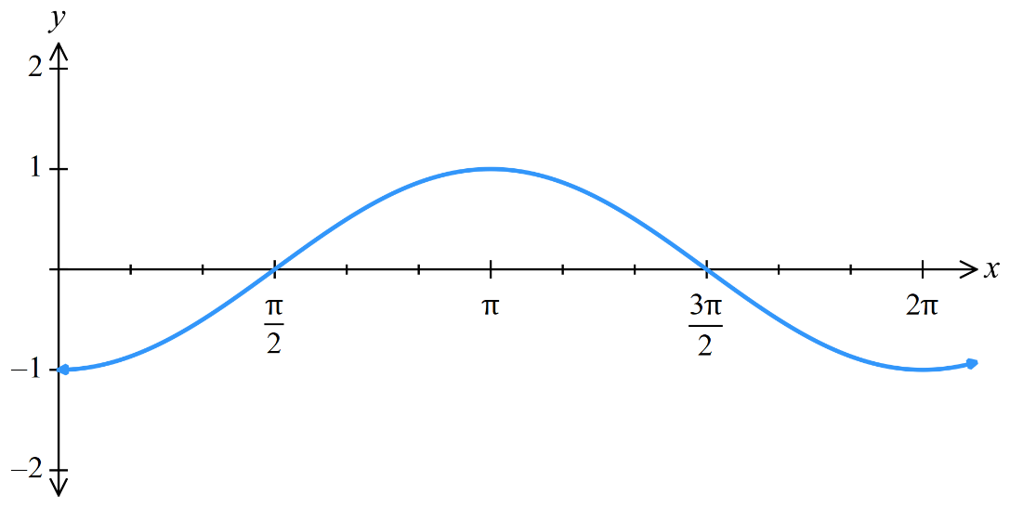  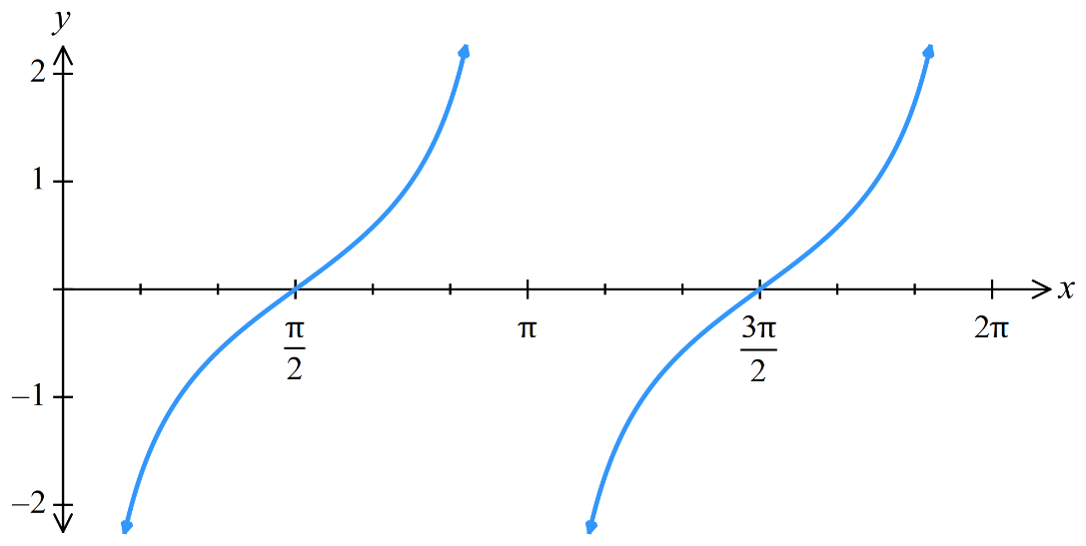  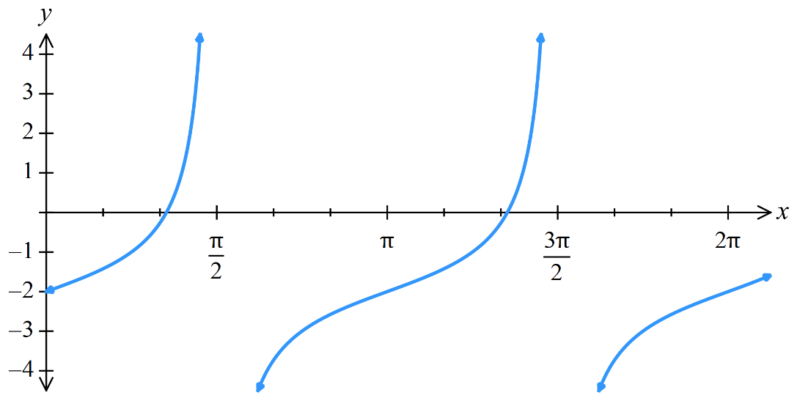  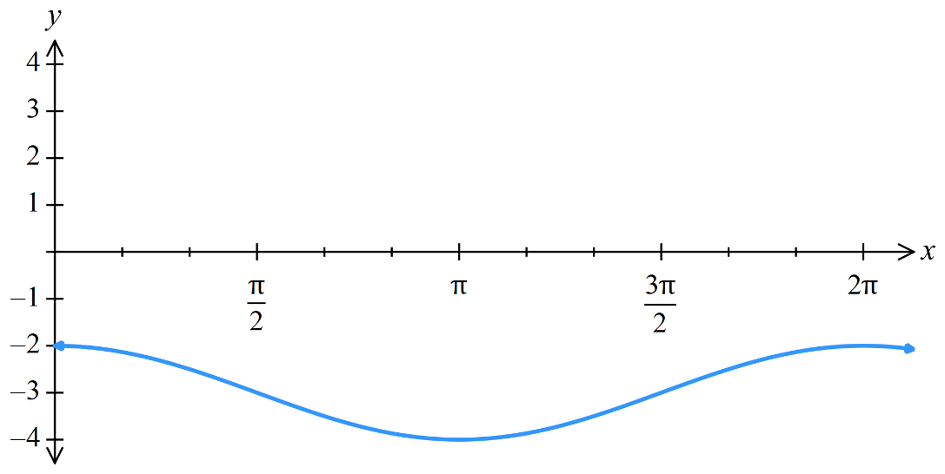
- $y=\cos\left(x+π\right)$ | - $y=\tan\left(x-\frac{π}{2}\right)$
- $y=-\cos{x}$ | - $y=-2\sin{x}$
- $y=\tan{2x}$  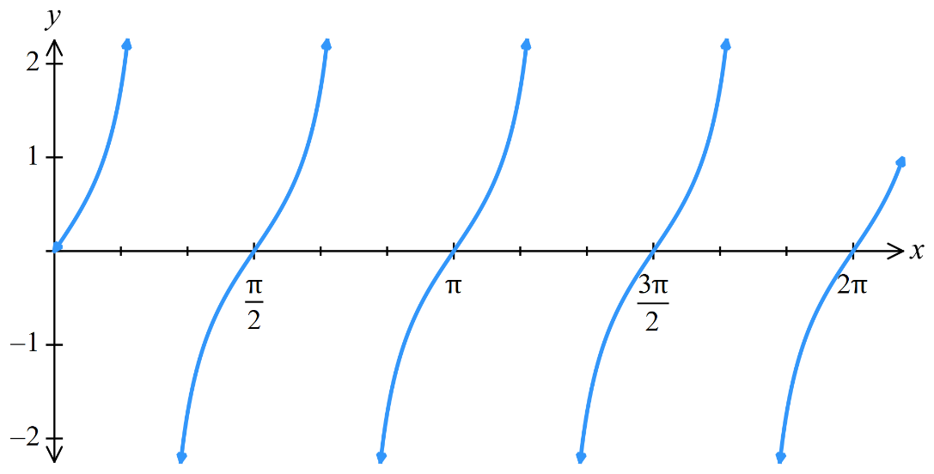 | - $y=\tan\left(\frac{x}{4}\right)$  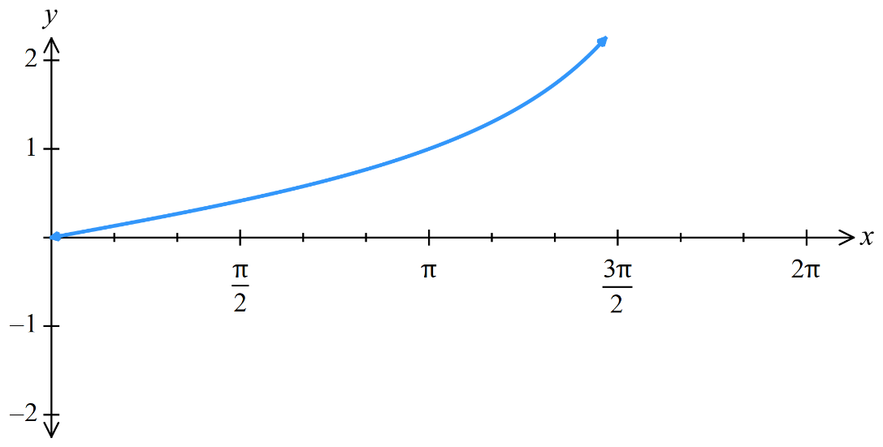
- $y=\sin\left(x-\frac{π}{4}\right)$
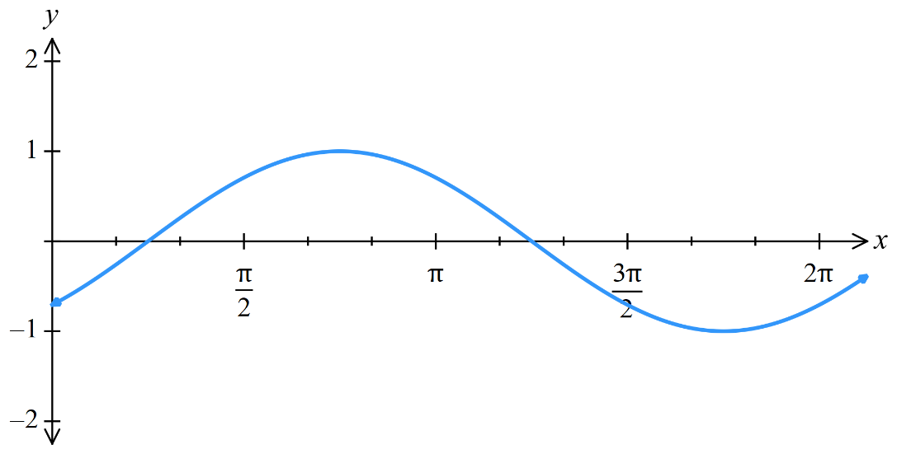

Development
- Sketch $y=k\sin{x}$ on DESMOS and create a slider for $k$.
Describe how the graph changes as $k$ increases.

As $k$ increases, the graph gets stretched vertically.

- Sketch $y=\sin\left(ax\right)$ on DESMOS and create a slider for $a$.
Describe how the graph changes as $a$ increases.

As $a$ increases, the graph gets compressed horizontally.

- Sketch $y=\sin\left(x\right)+c$ on DESMOS and create a slider for $c$.
Describe how the graph changes as $c$ increases.

As $c$ increases, the graph shifts upwards.

- Sketch $y=\sin\left(x+b\right)$ on DESMOS and create a slider for $b$.
  - Describe how the graph changes as $b$ increases.

As $b$ increases, the graph shifts left.

  - What happens when $b$ is a multiple of $2π$? Explain why with reference to the unit circle.

The graph returns to its original position.
On a unit circle, when the angle of inclination is a multiple of $2π$, the $y$-value returns to its original position.

Combined Transformations

- Combined Transformations
horizontal translation vertical translation

$$y=k\sin\left(a\left(x-b\right)\right)+c$$

vertical dilation factor $k$ horizontal dilation factor $\frac{1}{a}$

- Identify transformations in the form $y=k\sin\left(a\left(x-b\right)\right)+c$
- $y=3\sin\left(2\left(x+5\right)\right)-1$  - V. dilation factor ……………  - V. translation ……………  - H. dilation factor ……………  - H. translation …………… | - $y=2\sin\left(3\left(x-4\right)\right)+11$  - V. dilation factor ……………  - V. translation ……………  - H. dilation factor ……………  - H. translation ……………
- $y=4\tan\left(\frac{x}{5}\right)-13$  - V. dilation factor ……………  - V. translation ……………  - H. dilation factor ……………  - H. translation …………… | - $y=\frac{\sin\left(3\left(x-5\right)\right)}{3}+1$  - V. dilation factor ……………  - V. translation ……………  - H. dilation factor ……………  - H. translation ……………
- $y=3\cos\left(7x\right)$  - V. dilation factor ……………  - V. translation ……………  - H. dilation factor ……………  - H. translation …………… | - $y=\sin\left(x-3\right)+4$  - V. dilation factor ……………  - V. translation ……………  - H. dilation factor ……………  - H. translation ……………

- Combined Transformations
When combining transformations, we must first write the function in this form:
horizontal translation vertical translation

$$y=k\sin\left(a\left(x-b\right)\right)+c$$

vertical dilation factor $k$ horizontal dilation factor $\frac{1}{a}$

- Rewrite trigonometric function in the form $y=k\sin\left(a\left(x-b\right)\right)+c$
Write the following in the form $y=k\sin\left(a\left(x-b\right)\right)+c$ and identify the transformations.
- $y=3\sin\left(2x+\frac{π}{4}\right)$  - V. dilation factor ……………  - V. translation ……………  - H. dilation factor ……………  - H. translation …………… | - $y=8\cos{(πx}-2)-3$  - V. dilation factor ……………  - V. translation ……………  - H. dilation factor ……………  - H. translation ……………
- $y=3\tan\left(5x+\frac{π}{2}\right)+2$  - V. dilation factor ……………  - V. translation ……………  - H. dilation factor ……………  - H. translation …………… | - $y-7=\sin\left(\frac{x}{3}+2\right)+1$  - V. dilation factor ……………  - V. translation ……………  - H. dilation factor ……………  - H. translation ……………
- $2y=4\tan\left(2x+π\right)-6$  - V. dilation factor ……………  - V. translation ……………  - H. dilation factor ……………  - H. translation …………… | - $y+2=\frac{3\cos\left(3x-2π\right)-12}{6}$  - V. dilation factor ……………  - V. translation ……………  - H. dilation factor ……………  - H. translation ……………

- Combined Transformations
1. Write the function in this form:
$$y=k\sin\left(a\left(x-b\right)\right)+c$$

2. Determine order of transformations:
- Horizontal dilation $(a)$, then horizontal translation $(b)$
- Vertical dilation $(k)$, then vertical translation $(c)$
It doesn’t matter whether you do horizontal or vertical transformations first, but you must do dilation before translation.

3. Sketch each transformation step by step. You may need to solve for the intercepts.

- Example Sketch combined transformations of trigonometric functions
Sketch $y=3\cos\left(2x+\frac{π}{2}\right)$in the domain $\left[-2π,2π\right]$ by first stating the order of transformations.
1. $y=3\cos\left(2\left(x+\frac{π}{4}\right)\right)$
2.
1. Horizontal dilation by $\frac{1}{2}$ (compressed horizontally). 2. Horizontal translation by $\frac{π}{4}$ left.
3. Vertical dilation by 3 (stretched vertically). 4. No vertical translation.
3.
$$y=\cos{x}$$  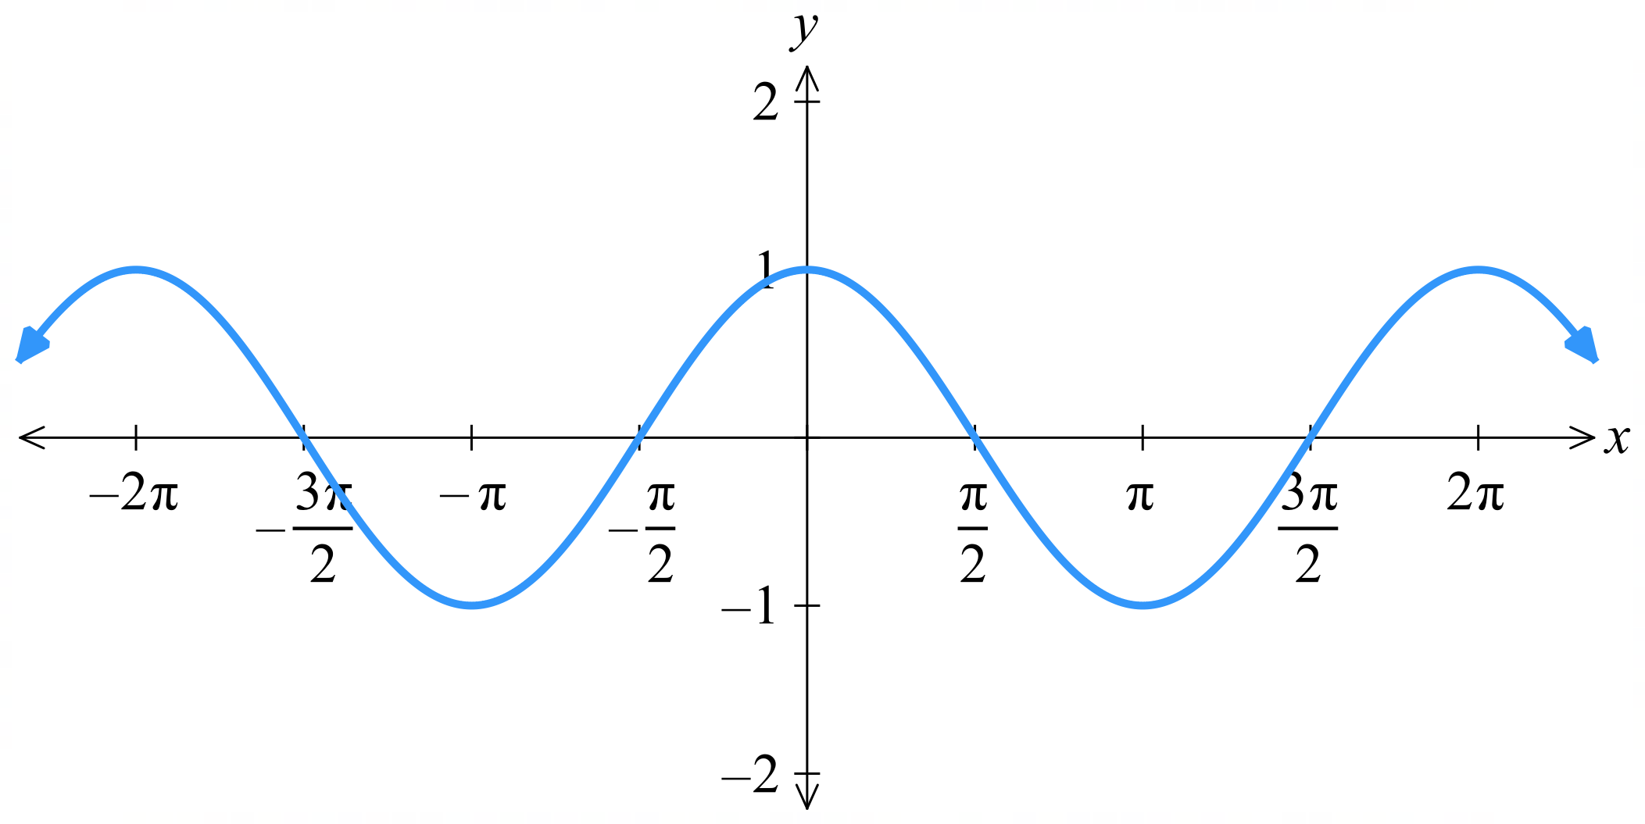 | $$y=\cos{(2x})$$  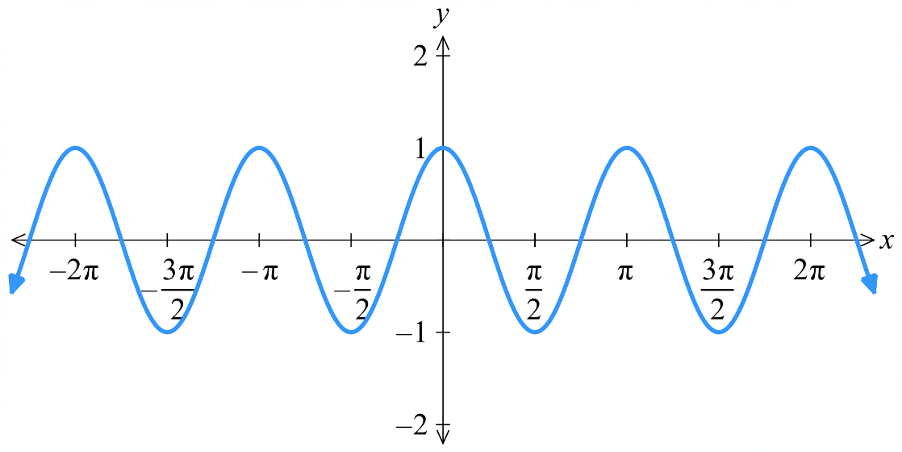
$$y=\cos\left(2\left(x+\frac{π}{4}\right)\right)$$  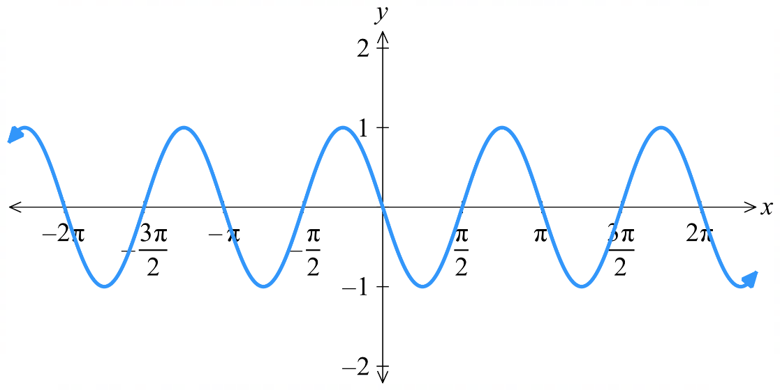 | $$y=3\cos\left(2\left(x+\frac{π}{4}\right)\right)$$  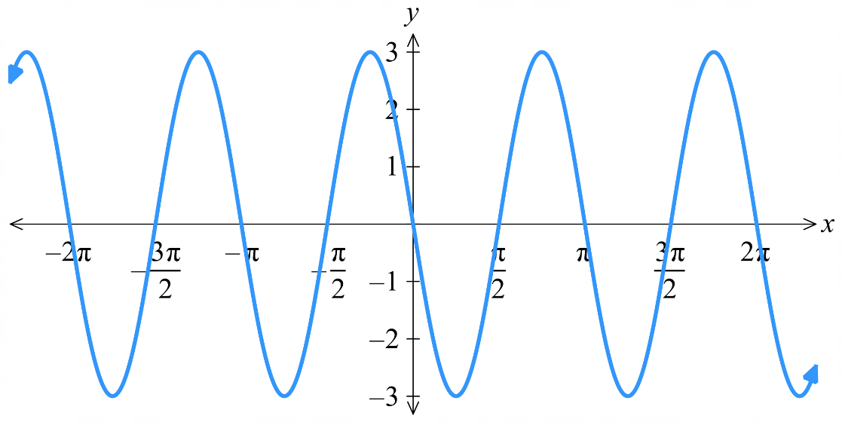
- Guided Practice
Sketch $y=\sin\left(\frac{x}{2}-\frac{π}{6}\right)$in the domain $\left[-2π,2π\right]$ by first stating the order of transformations.

$$y=\sin\left(\frac{1}{2}\left(x-\frac{π}{3}\right)\right)$$
1. horizontal dilation factor 2 2. Horizontal translation right by $\frac{π}{3}$
$$y=\sin{x}$$  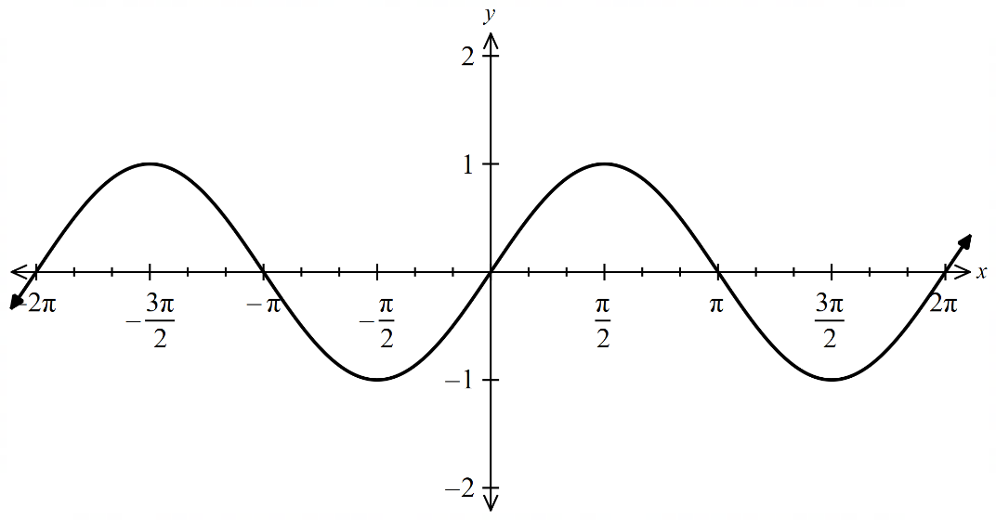 | $$y=\sin\left(\frac{x}{2}\right)$$  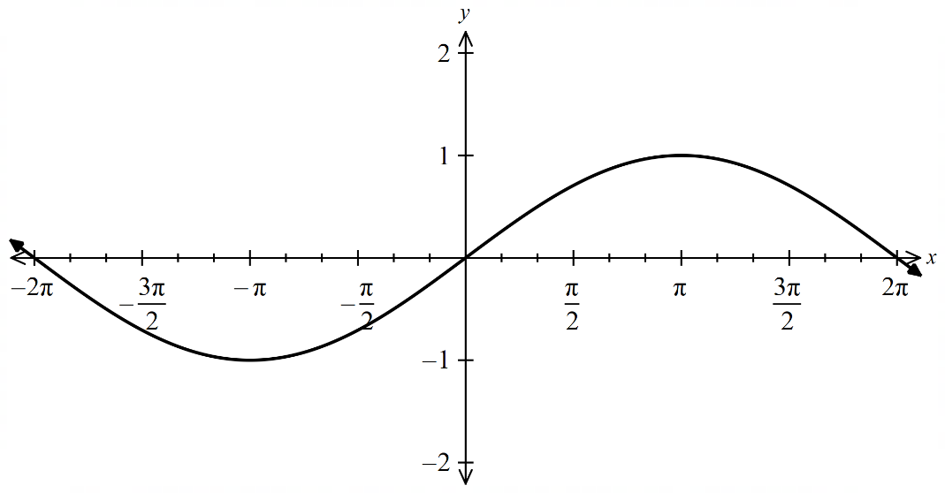
$$y=\sin\left(\frac{x}{2}-\frac{π}{6}\right)$$  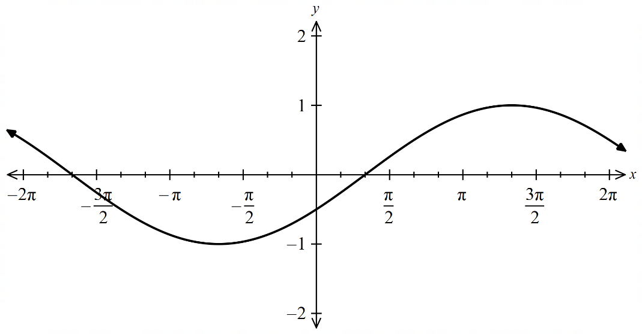 | - you can also do horizontal translation right by $\frac{π}{6},$ then horizontally dilate by factor 2

- Guided Practice
Sketch $y=2\cos\left(\frac{πx}{12}\right)+1$, starting at $x=0$ for one cycle by stating the order of transformations and then stating the amplitude, mean position, and period.

1. horizontal dilation by factor $\frac{12}{π}$
2. vertical dilation by factor 3. vertical translation up by 1
Amplitude: 2, mean position: 1, period: 24

$$y=\cos\left(\frac{πx}{12}\right)$$  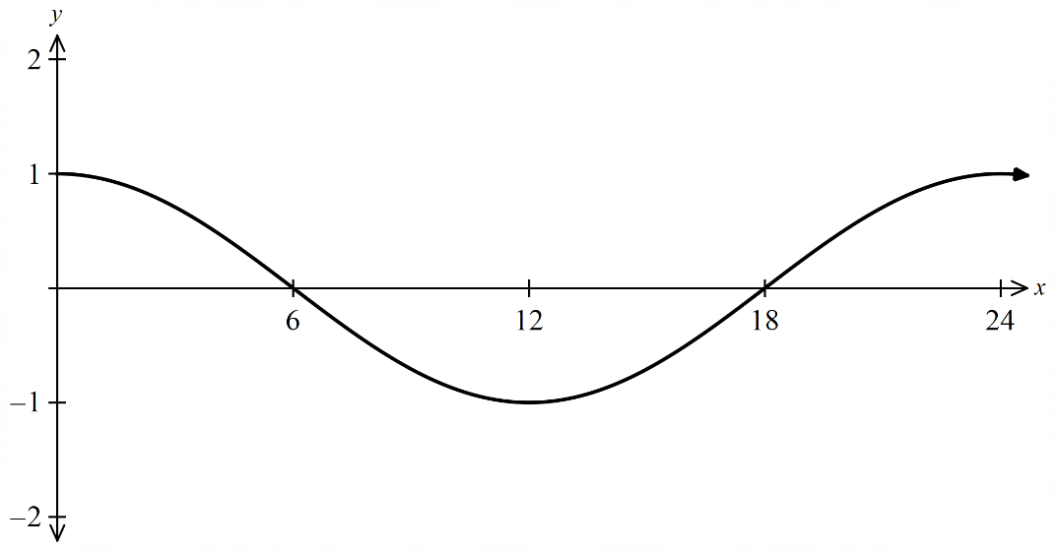 | $$y=2\cos\left(\frac{πx}{12}\right)$$  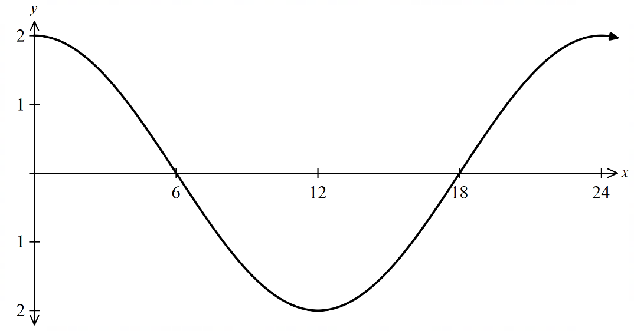
$$y=2\cos\left(\frac{πx}{12}\right)+1$$  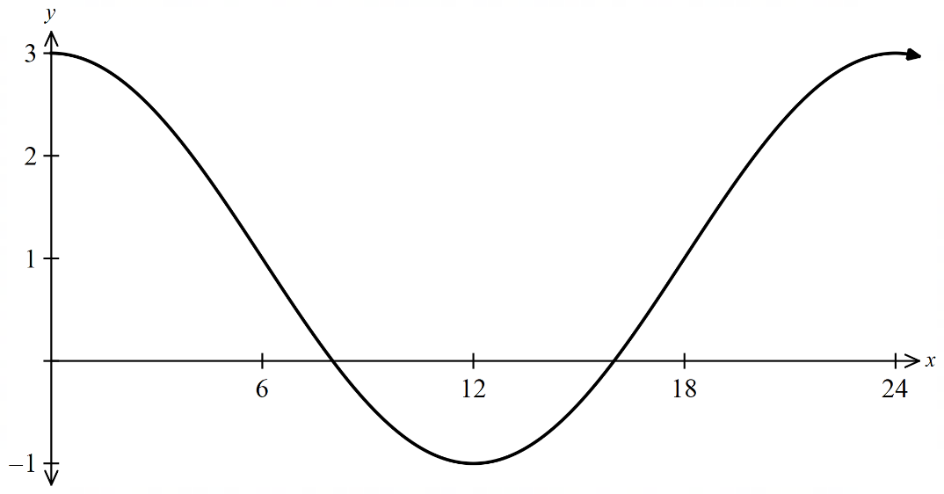 | - you can sketch the entire curve all in one go using the amplitude, mean position, and period. If required to find the intercepts, we can set the equation to 0 and solve.

Foundation
- Sketch the graph of each function in the domain $\left[0,2π\right]$.
- $y=2\sin\left(x\right)-3$  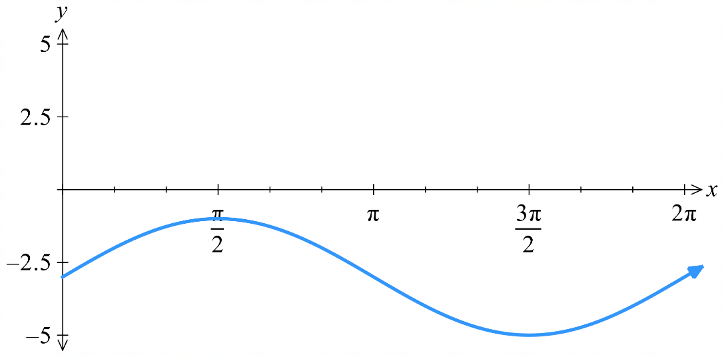 | - $y=-\tan{2x}$  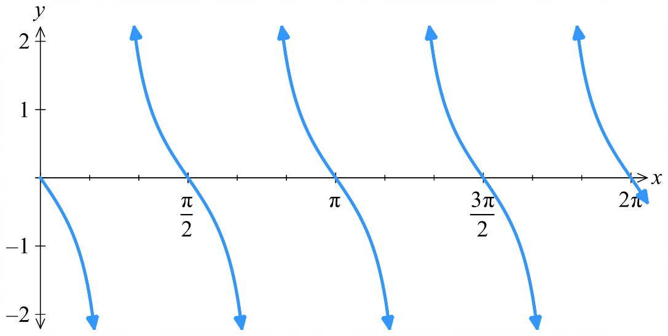
- $y=\cos\left(x+\frac{π}{2}\right)+1$  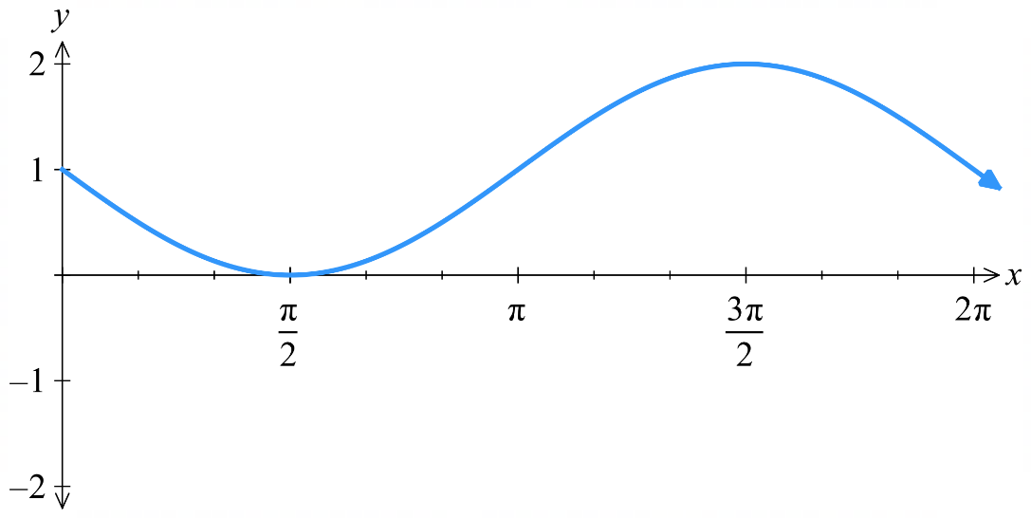 | - $y=\sin\left(-\frac{x}{2}\right)+2$  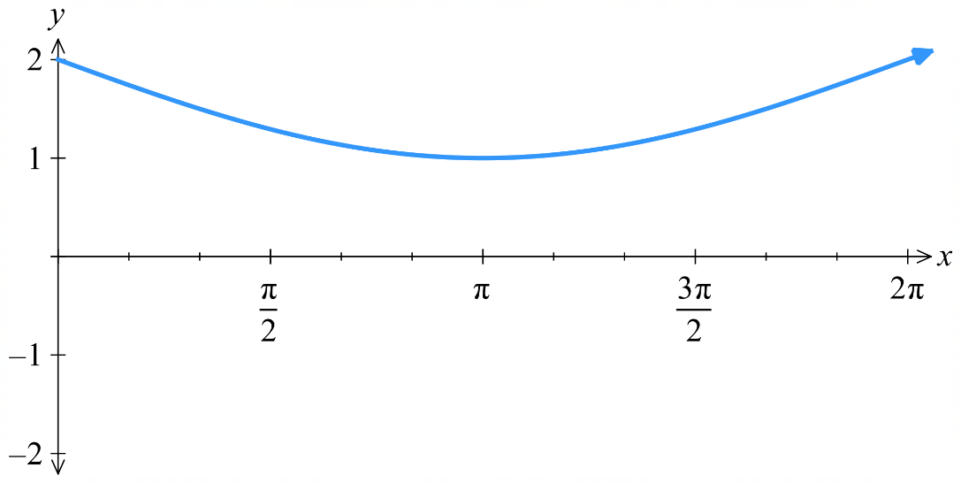

- State the amplitude and period of each function, then sketch its graph for $\left[-π,π\right]$.
- $y=3\cos\left(2x\right)$  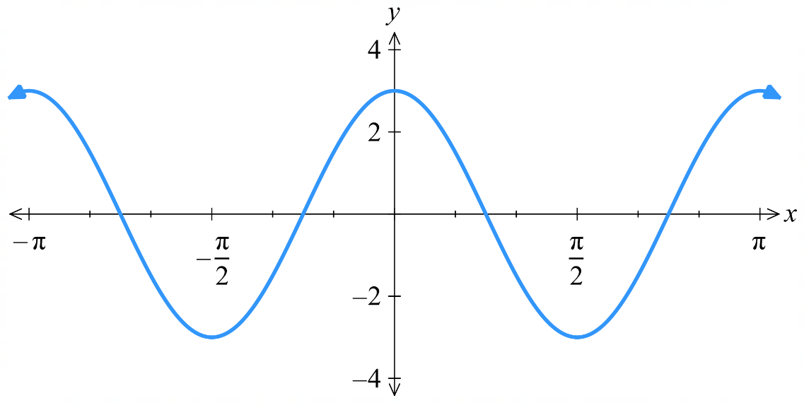  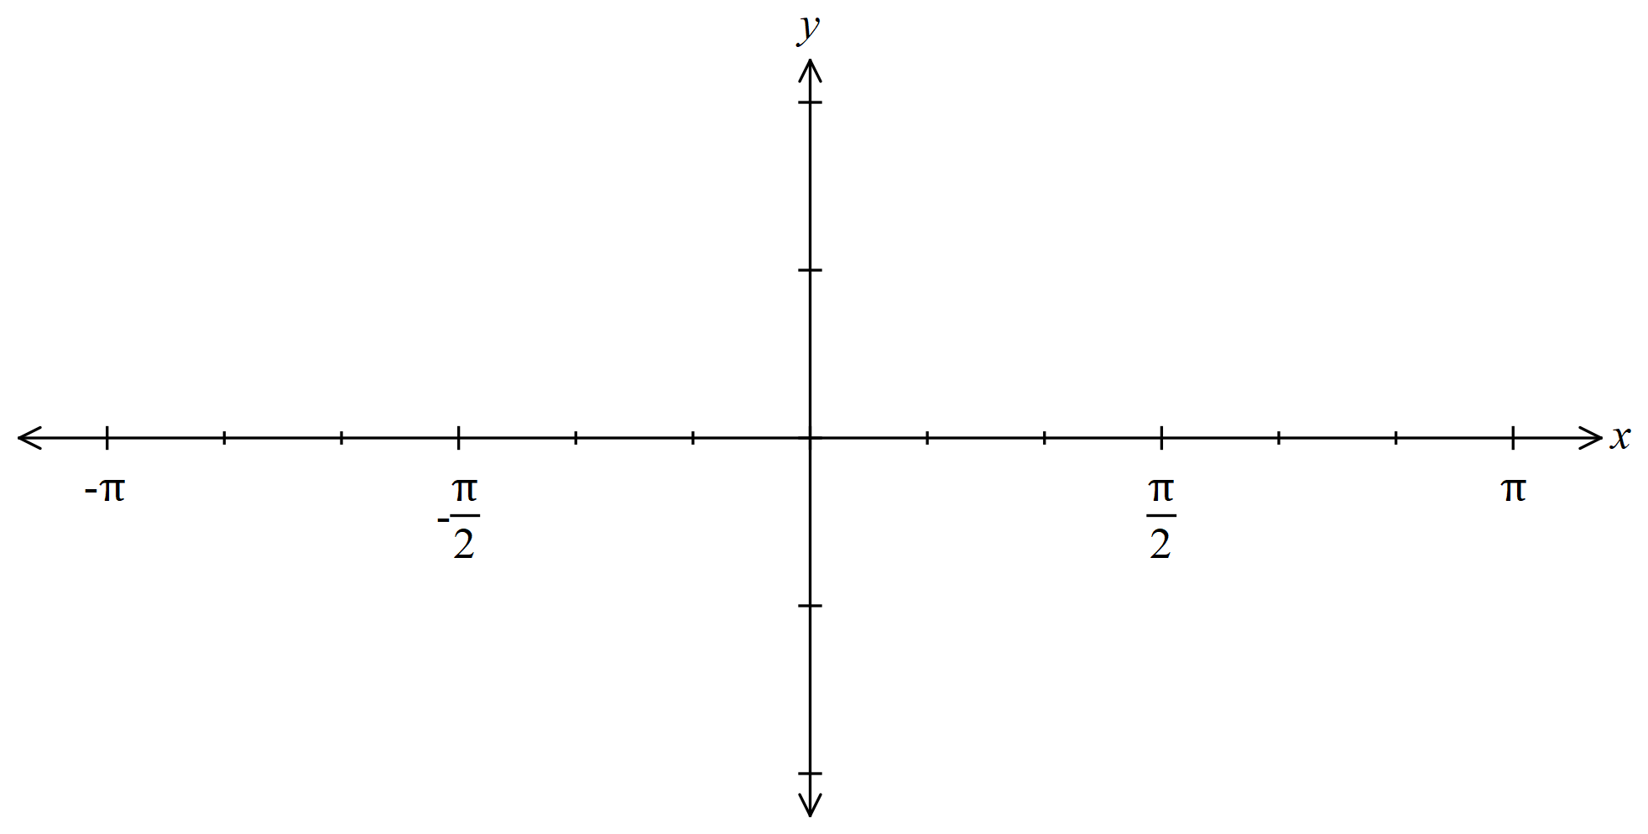 | - $y=2\sin\left(\frac{x}{2}\right)$  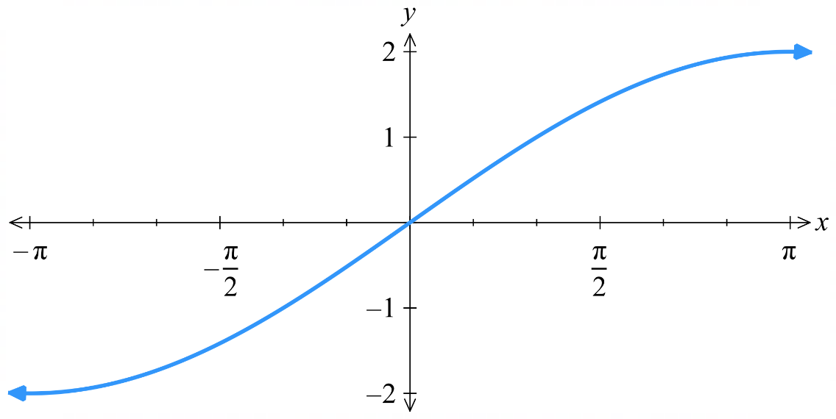
- $y=\tan\left(\frac{3x}{2}\right)$  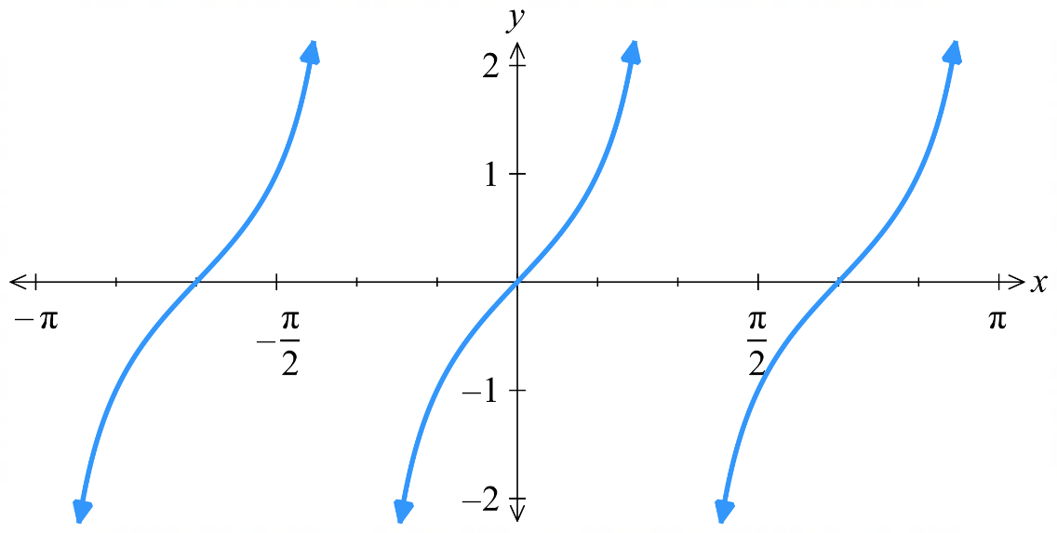 | - $y=2\cos\left(3x\right)$  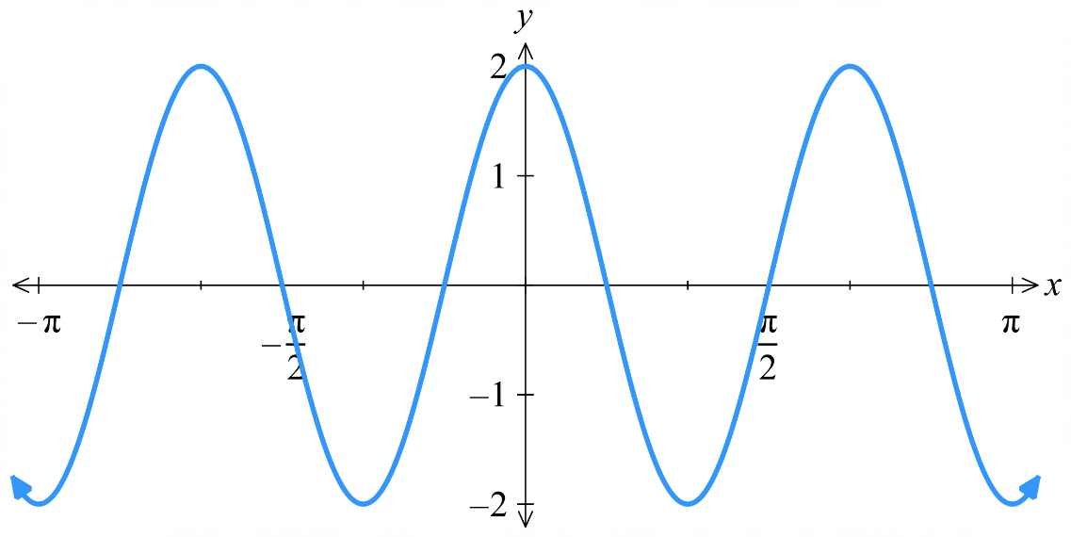
- State the sequence of transformations that will transform $y=\sin{x}$ to the given function, then sketch for the domain $\left[0,2π\right]$.
- $y=-2\sin\left(\frac{x}{2}\right)$  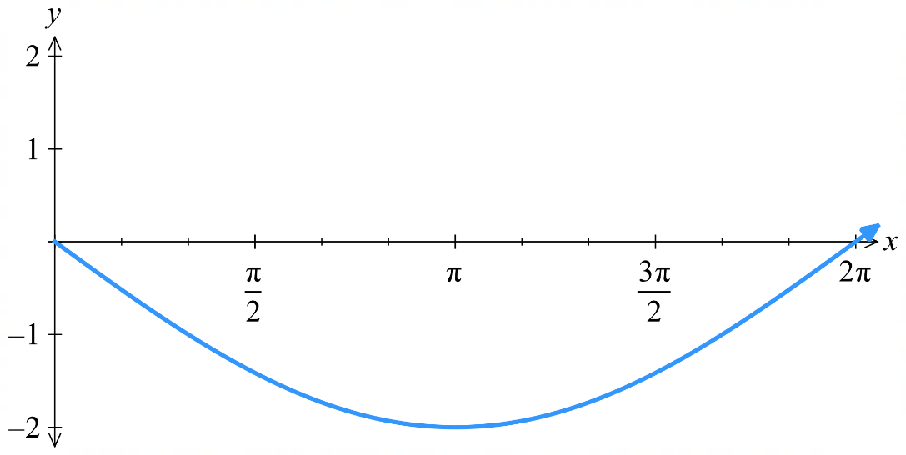  Dilate horizontally by factor 2  Dilate vertically with factor 2 and reflect across $x$ axis | - $y=3\sin\left(x-\frac{π}{2}\right)+2$  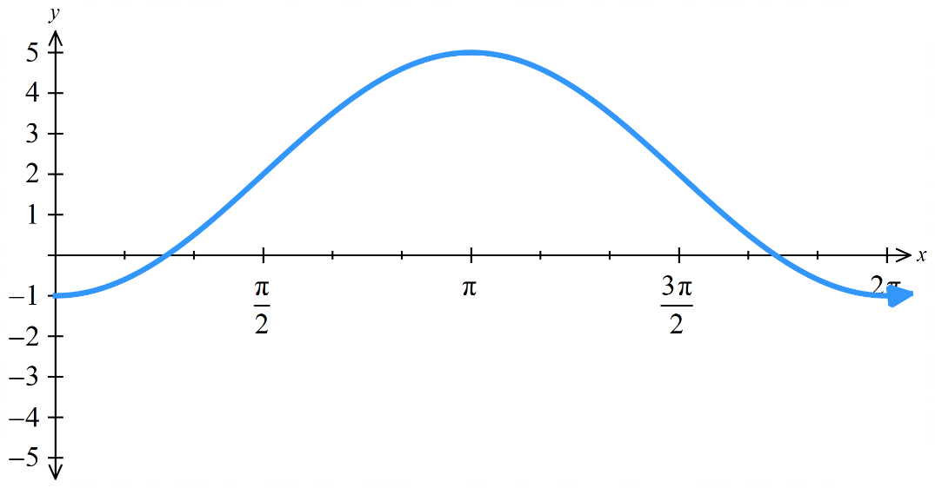  Shift $\frac{π}{2}$ units right  Dilate vertically by factor 3  Shift 2 units up

- State the sequence of transformations that will transform $y=\cos{x}$ to the given function, then sketch for the domain $\left[0,2π\right]$.
- $y=5\cos\left(\frac{x}{2}\right)$  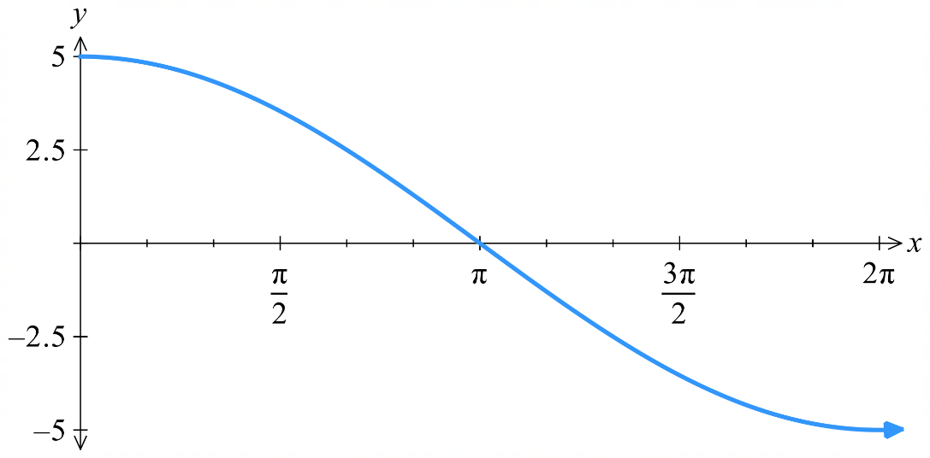  Dilate horizontally by factor 2  Dilate vertically by factor 5 | - $y=\cos\left(2\left(x-\frac{π}{2}\right)\right)$  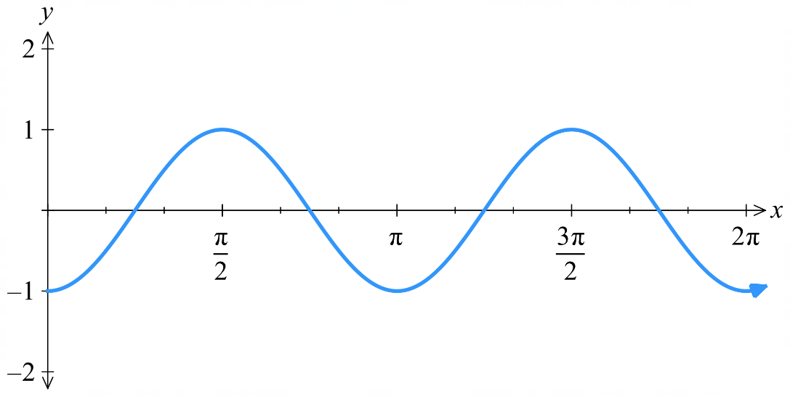  Dilate horizontally by factor $\frac{1}{2}$  Shift $\frac{π}{2}$ units right

- Identify the amplitude, period, and phase of these functions.
- $y=\sin\left(3x+\frac{π}{2}\right)$  Amplitude: 1  Period: $\frac{2π}{3}$  Phase: $\frac{π}{6}$ (shift left) | - $y=-6\sin\left(\frac{x}{2}+\frac{π}{4}\right)$  Amplitude: 6  Period: $4π$  Phase: $\frac{π}{2}$ (shift left)
- $y=3\sin\left(2x-\frac{2π}{3}\right)$  Amplitude: 3  Period: $π$  Phase: $-\frac{π}{3}$ (shift right) | - $y=\frac{5\cos\left(\frac{x+π}{3}\right)}{2}$  Amplitude: 2.5  Period: $6π$  Phase: $π$ (shift left)

Development
- Sketch one cycle for each function starting from $x=0$.
- $y=2\cos\left(3x+π\right)$  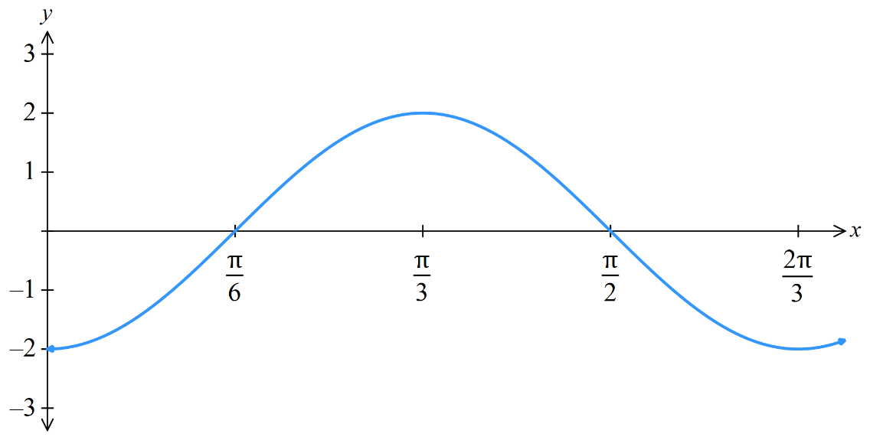  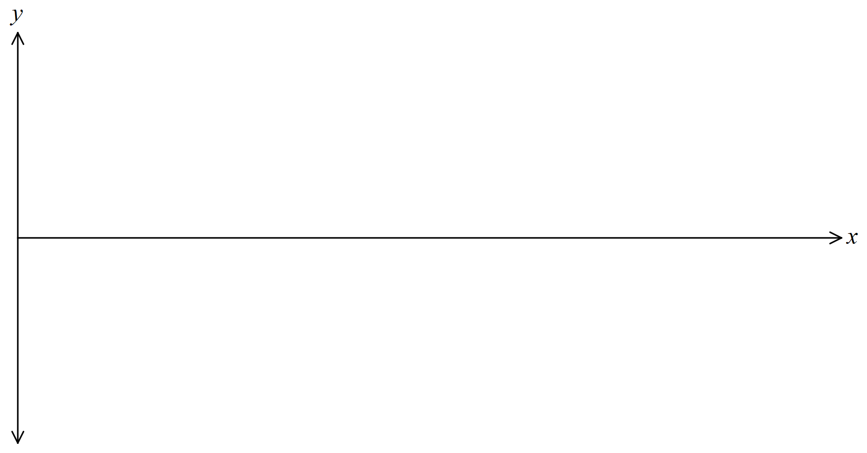 | - $y=3\sin\left(2x-\frac{π}{2}\right)$  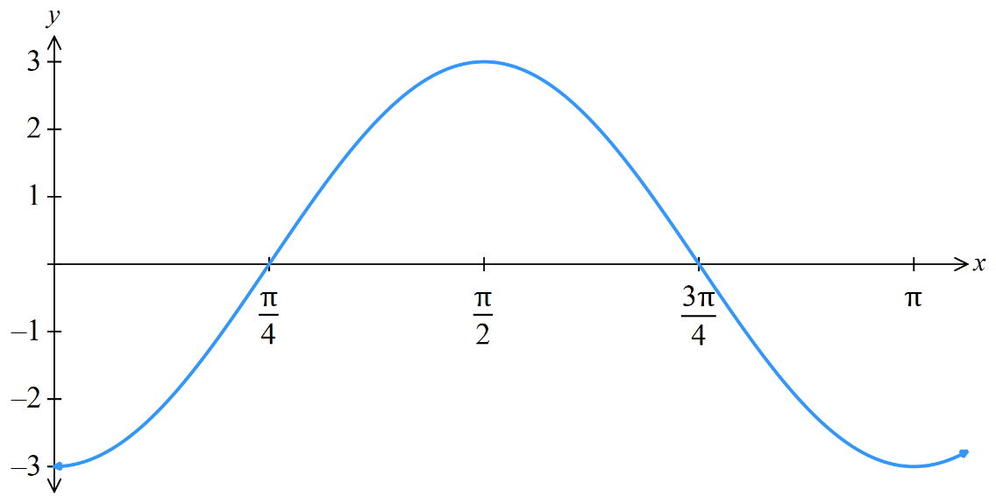
- $y=15\sin\left(\frac{πt}{12}\right)+20$  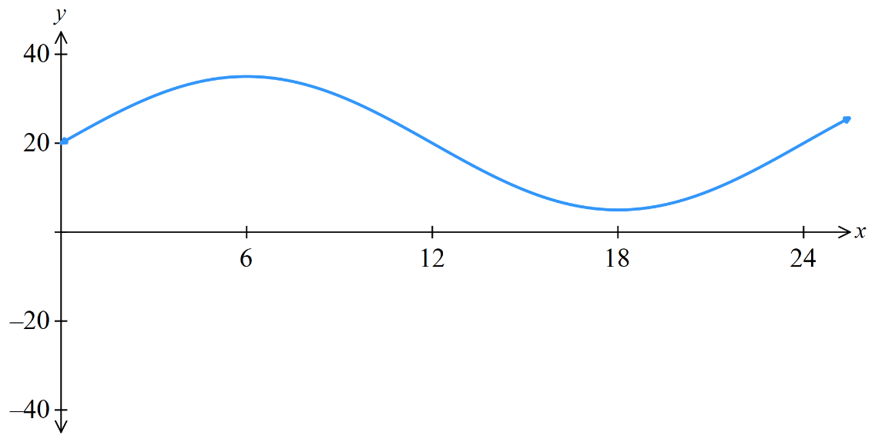 | - $y=2\cos\left(\frac{πx}{3}\right)+4$  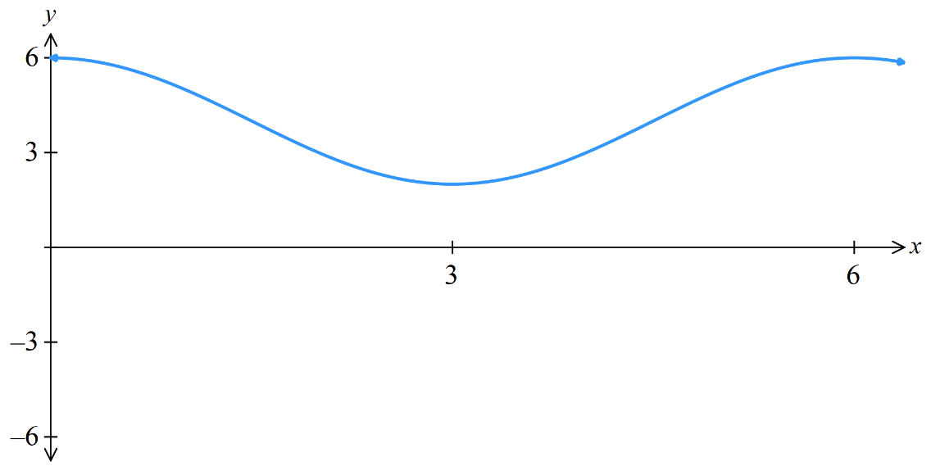

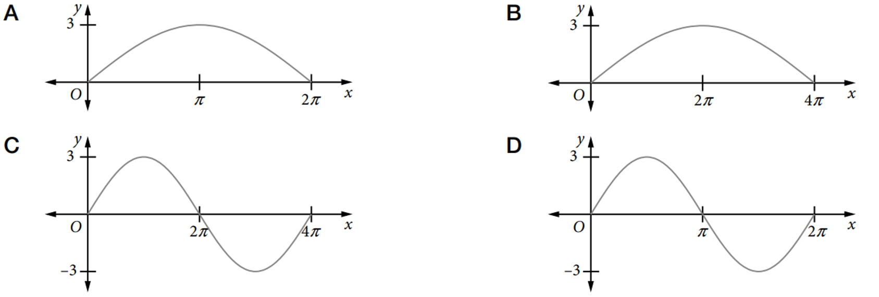
- Which diagram shows the graph of $3\sin\left(\frac{x}{4}\right)$?

B

Solving Trigonometric Equations Algebraically & Graphically

- Review
- Solve trigonometric equations involving compound angles.
- Let $u$ be the compound angle.
- Determine the domain for $u$.
- Solve the trigonometric equation for $u$.
- Substitute to solve for $x$.

Solve in the domain $0≤x≤2π$.
- $\sin\left(2x\right)=\frac{\sqrt{3}}{2}$  $$\frac{π}{6},\frac{π}{3},\frac{7π}{6},\frac{4π}{3}$$ | - $\sqrt{3}\tan\left(x+\frac{π}{3}\right)=1$  $$\frac{5π}{6},\frac{11π}{6}$$

Solve in the domain $-π≤x≤π$.
- $2\sin\left(3x\right)=1$  $$-\frac{11π}{18}, -\frac{7π}{18},\frac{π}{18},\frac{5π}{18},\frac{13π}{18},\frac{17π}{18}$$ | - $2\cos\left(2x+\frac{π}{3}\right)=1$  $$-π, -\frac{π}{3}, 0,\frac{2π}{3}, π$$

Solve in the domain $0≤x≤2π$.
- $\sqrt{2}\sin\left(\frac{x}{2}-\frac{π}{3}\right)=1$

$$\frac{7π}{6}$$

- Solving Trigonometric Equations Graphically
A trigonometric equation can be solved graphically by:
1. Sketching LHS and RHS
2. Finding the $x$-coordinates of the point of intersection.
Some equations can only be solved graphically, as there is no possible algebraic technique.
Sketching can also be useful to see how many solutions there are in a domain.

- Investigation Graphical solutions to trigonometric equations.
Solve $2\sin\left(3x\right)=1$ for $0≤x≤2π$ by following these steps:
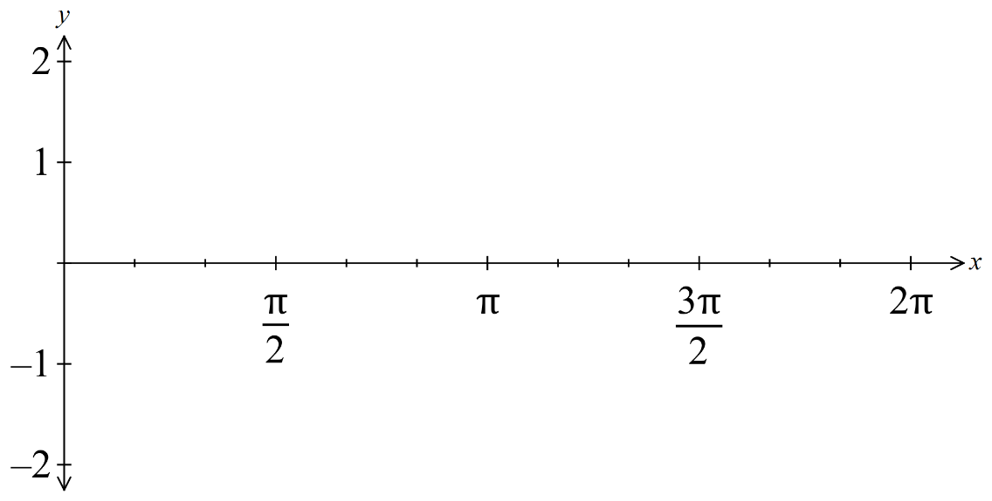
1. Sketch $y= LHS$ and $y= RHS$ on the same set of axes.

2. Identify how many solutions you expect.

3. Find the solutions algebraically.

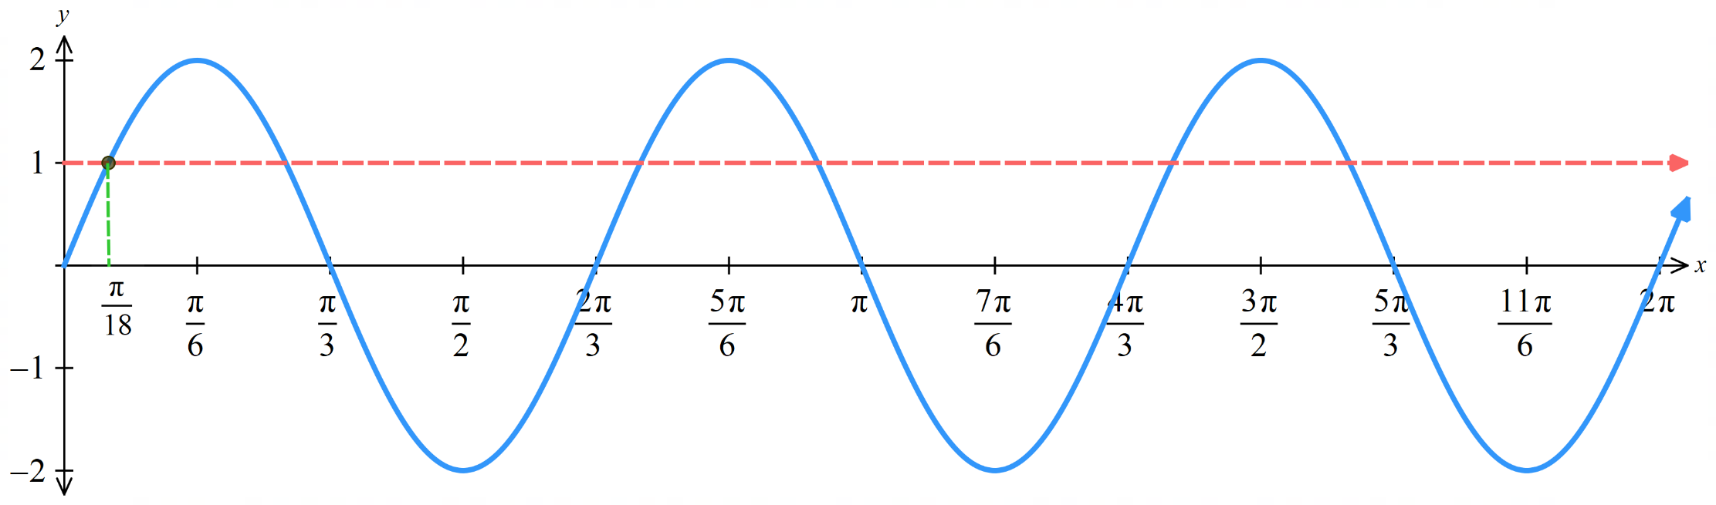
4. Alternate method
Once you find the first solution, use symmetry and period to find other solutions.

Foundation
- Solve each equation algebraically in the domain $\left[0,2π\right]$ and indicate the solutions on the graph.
- $2\sin\left(x-\frac{π}{3}\right)=1$  $$x=\frac{π}{2},\frac{7π}{6}$$ | - $2\cos{(2x)}=-1$  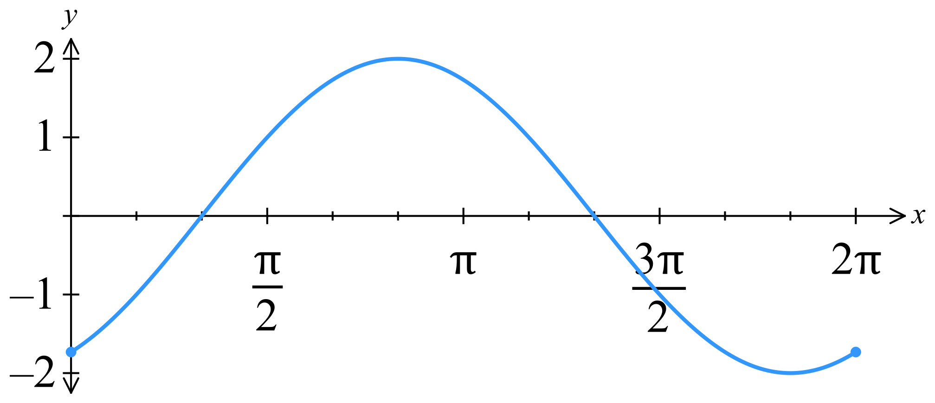  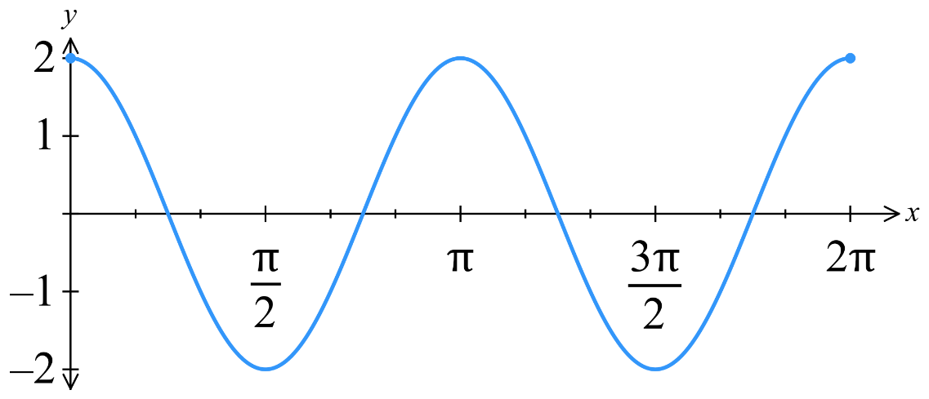  $$x=\frac{π}{3},\frac{2π}{3},\frac{4π}{3},\frac{5π}{3}$$

- Which graph could be used to solve $\sin{x}=x-1$?
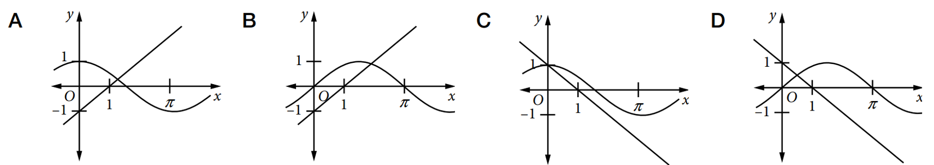

B

Development
- In the given diagram, the curve $y=\sin{2x}$ is graphed for the domain $\left[-π,π\right]$.
The line $y=\frac{x}{2}-\frac{1}{4}$ is also graphed.
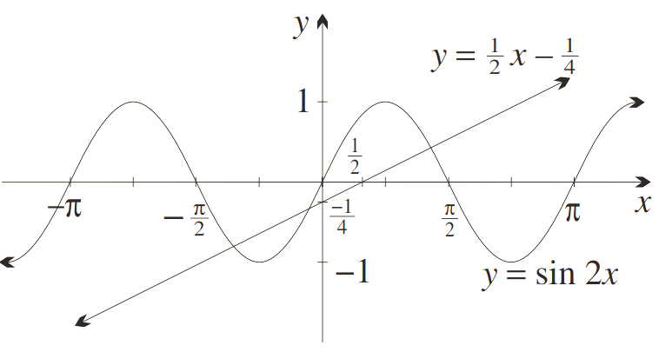

  - How many points of intersection are there for the two graphs?
3
  - Therefore, how many solutions are there for $\sin{2x}=\frac{x}{2}-\frac{1}{4}$, and how many are positive?
3; only 1 positive
  - Briefly explain why the line will not meet the curve outside of the domain $x∈\left[-π,π\right]$.

Outside this domain the range of the line is not within the range of the sine curve.

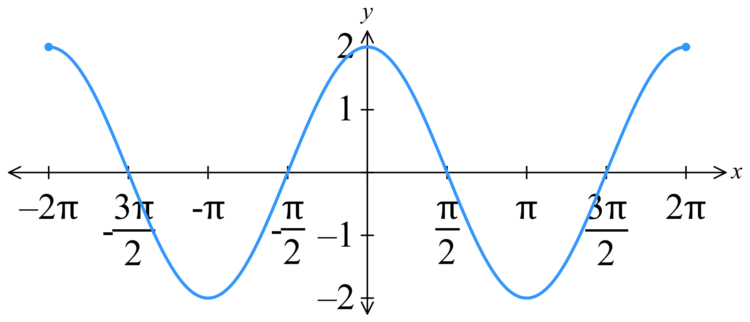
  - Sketch the graph of $y=2\cos{x}$ for the domain $-2π≤x≤2π$.
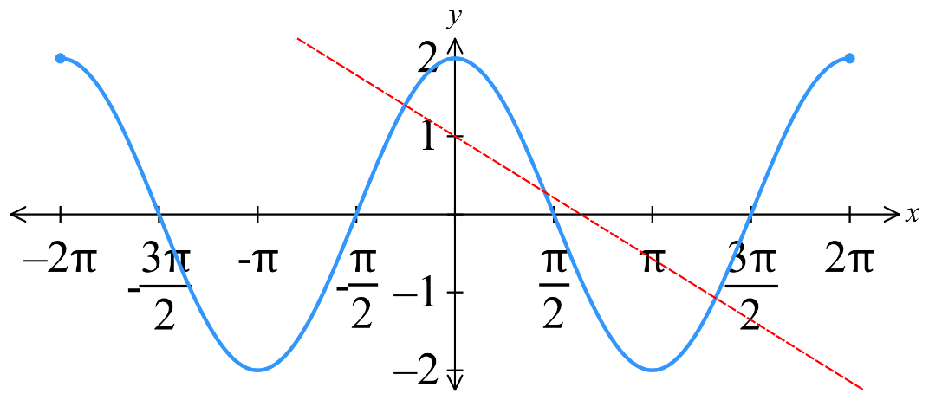

  - On the same diagram, carefully sketch the line $y=1-\frac{x}{2}$ showing its $x$ and $y$ intercepts.
  - How many solutions does the equation $2\cos{x}=1-\frac{x}{2}$ have?
3
  - Prove algebraically that if $n$ is a solution of the equation in part c, then $-2≤n≤6$.
Hint: consider the range of $\cos{n}$.
$$since -1≤\cos{n}≤1$$
$$-2≤2\cos{n}≤2$$
$$-2≤1-\frac{n}{2}≤2$$
$$-3≤-\frac{n}{2}≤1$$
$$6≥n≥-2$$
$$∴-2≤n≤6$$

  - What is the period of the function $y=\sin\left(\frac{πx}{2}\right)?$
$$\frac{2π}{\left(\frac{π}{2}\right)}=4$$
  - Sketch the curve $y=1+\sin\left(\frac{πx}{2}\right)$ for $0≤x≤4$.
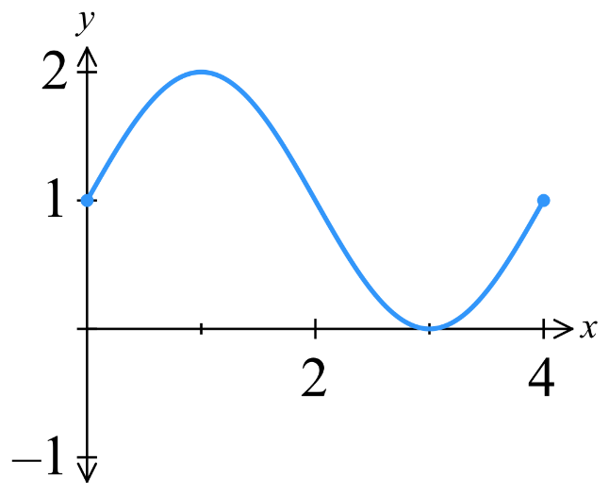

  - Through what fixed point must the line $y=mx$ pass, for any value of $m$?
The origin $\left(0,0\right)$
  - By considering possible points of intersection, find the values for $m$ for which the equation $\sin{\frac{πx}{2}}=mx-1$ has exactly one real solution in the domain $0≤x≤4$.
This is equivalent to considering points of intersection of $y=1+\sin\left(\frac{πx}{2}\right)$ and $y=mx$
By considering the graph, if the gradient of the straight line is negative, it will never meet the graph
If the gradient is 0, it will be tangent to the trough
Consider the line passing through (0,0) and (4,1), this line has gradient 0.25
If the gradient is between 0 and 0.25, it will cross the graph twice
If the gradient is greater than 0.25, it will cross the graph once
$∴m=0$ or $m>0.25$
https://www.desmos.com/calculator/c30d7arjoi

- Consider the graph of $f\left(x\right)$. You are given that $x=1.77$ is a solution to $f\left(x\right)=6$.
Find the other solutions in the domain $\left[0,24\right]$.
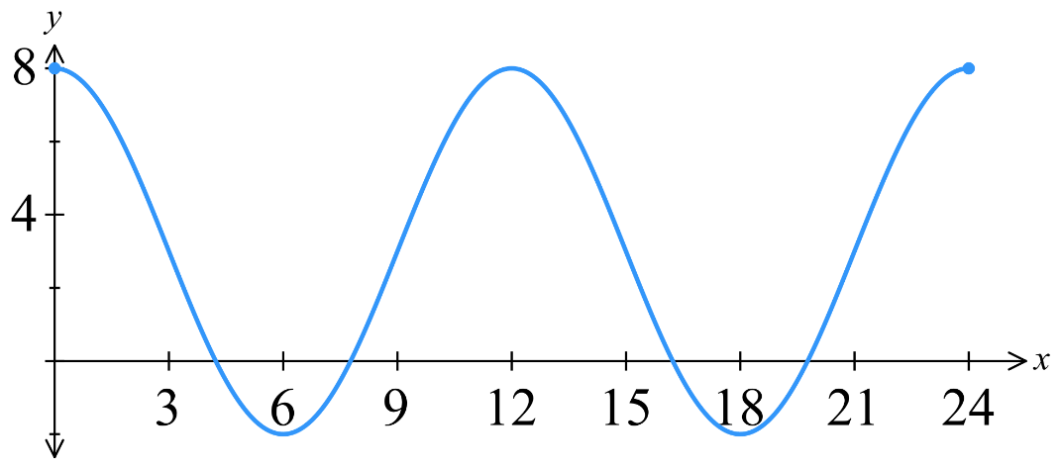

Period is 12
Trough at $x=6$; $x=1.77$ is $\left(6-1.77\right)=4.23$ from the trough
By symmetry, the other solution is $6+4.23=10.23$
Find another two solutions by adding $12$ to each solution
$$1.77+12=13.77;10.23+12=22.23$$
Check your answer on DESMOS using $y=5\cos\left(\frac{πx}{6}\right)+3$ and $y=6$

Exam Questions
- 2010 HSC Advanced Band 4
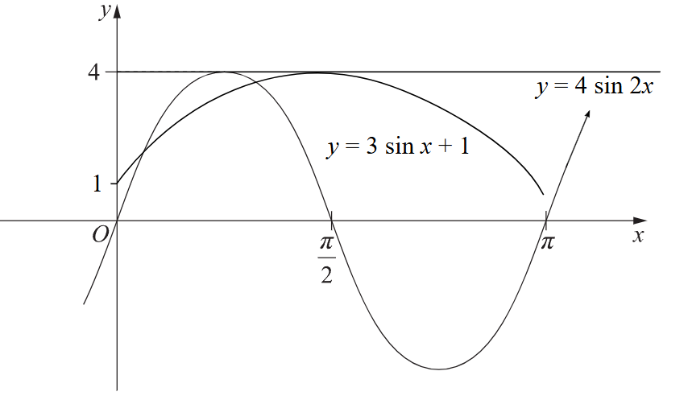
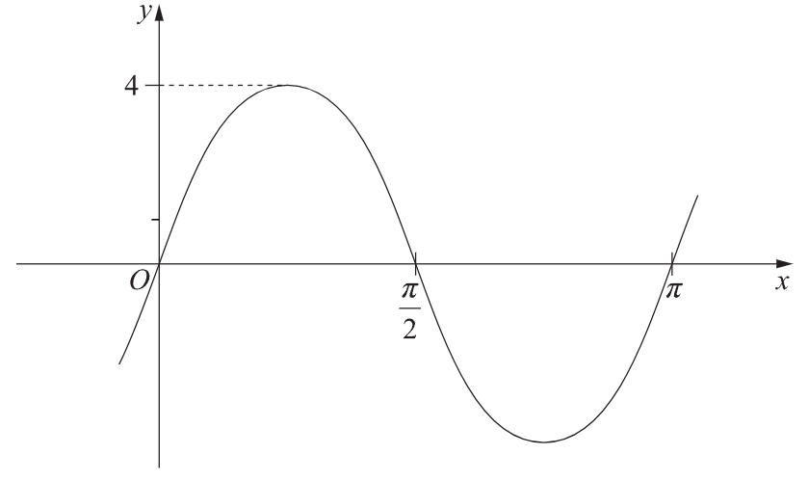
The graph shows $y=A\sin{bx}.$

  - Write the value of $A$.
  - Find the value of $b$.
  - On the same axes, sketch $y=3\sin{x}+1$.
$A=4$,
$b=2$ (from inspection; the graph has been dilated horizontally by a factor of $\frac{1}{2}$, alternatively you can substitute a point into the equation and solve)

- 2010 VCE Methods Band 4
Below is part of a function $y=\tan\left(ax+b\right).$
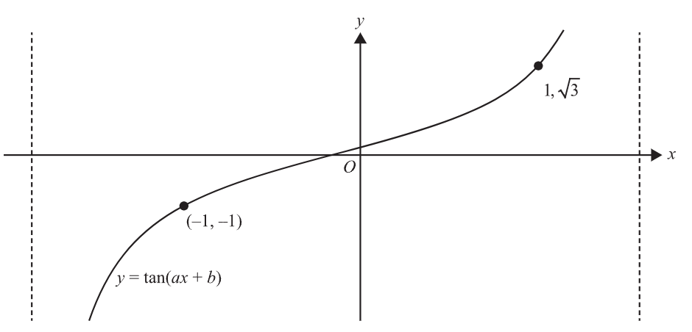
Find the value of $a$ and $b$, where $a>0$ and $0<b<1$.
Solve simultaneously using the two points.
$$\tan\left(a+b\right)=\sqrt{3}$$
$$a+b=\frac{π}{3} \left(1\right)$$
$$\tan\left(b-a\right)=-1$$
$$b-a=-\frac{π}{4} \left(2\right)$$

$$\left(1\right)+\left(2\right): b=\frac{π}{24}$$
$$∴a=\frac{7π}{24}$$
- 2021 HSC Advanced Band 4
For what values of $x$, in the interval $0≤x≤\frac{π}{4}$, does the line $y=1$ intersect the graph of
$y=2\sin{4x}$?

$$2\sin{4x}=1$$
$$\sin{4x}=\frac{1}{2}$$
$$4x=\frac{π}{6},\frac{5π}{6},\frac{13π}{6},\frac{17π}{6}, …$$
$$x=\frac{π}{24},\frac{5π}{24} \left(0≤x≤\frac{π}{4}\right)$$
- 2022 HSC Advanced Band 4
Consider the graph of $y=k\sin\left(ax\right)$.
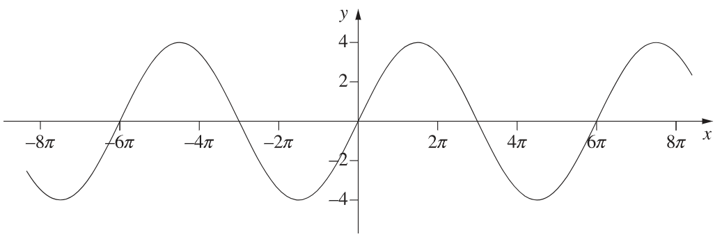
What are the values of $k$ and $a$?

Amplitude: $k=4$
Period: $6π$
$$\frac{2π}{a}=6π$$
$$a=\frac{1}{3}$$
- HSC Advanced Sample Question Band 4
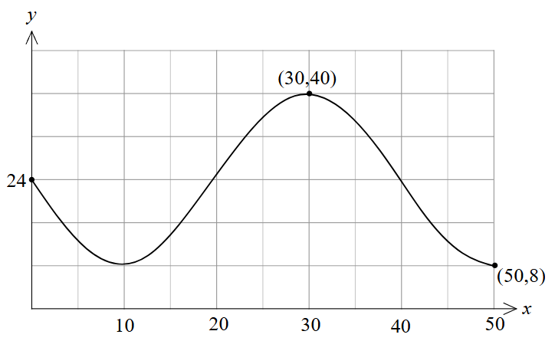
Determine the equation of the function below in the form $y=a\sin\left(bx\right)+c$.

Amplitude $a=$ $\frac{40-8}{2}$ $=16$
Mean position $c=24$
Period: 40
$$\frac{2π}{b}=40;b=\frac{π}{20}$$
$$∴y=-16\sin\left(\frac{πx}{20}\right)+24$$
- HSC Advanced Sample Question Band 4
State the range and period of the function $h\left(x\right)=4+3\cos\left(\frac{πx}{2}\right)$
Function oscillates between $4±3$
Range: $y∈\left[1,7\right]$
Period: 4

- 2016 HSC Advanced Band 5
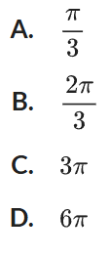
What is the period of $f\left(x\right)=\tan\left(3x\right)?$

A
Original period: $π$
New period: $\frac{π}{3}$

- 2013 HSC Advanced Band 5
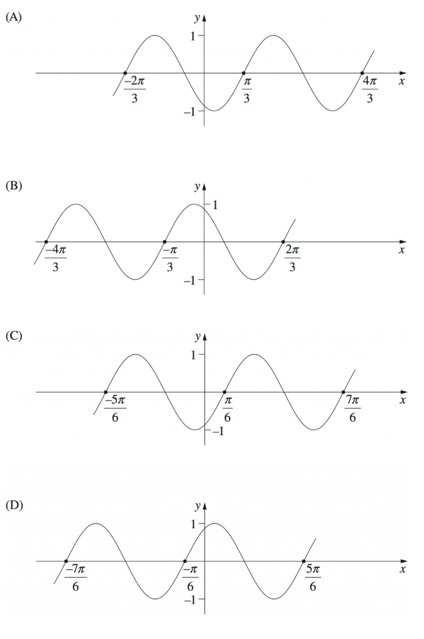
Which diagram shows the graph of $y=\sin\left(2x+\frac{π}{3}\right)$?

$$y=\sin\left(2\left(x+\frac{π}{6}\right)\right)$$
The only sine graph shifted left by $\frac{π}{6}$ is D
- HSC Advanced Sample Question Band 5
For the function $f\left(x\right)=5\cos\left(2\left(x+\frac{π}{3}\right)\right), -π≤x≤π$
  - Write the amplitude and period of the function.
Amplitude: 5, Period: $\frac{2π}{2}$ $=π$
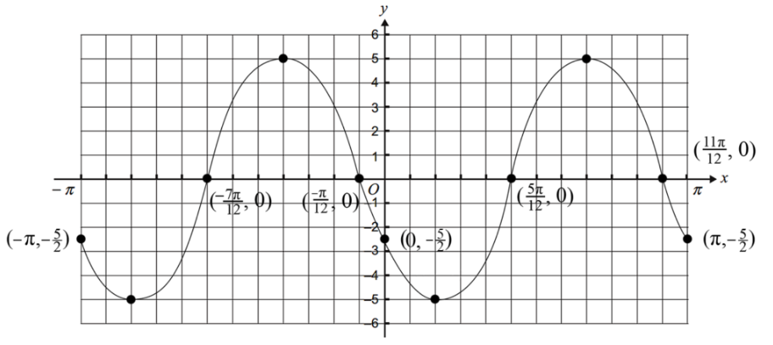
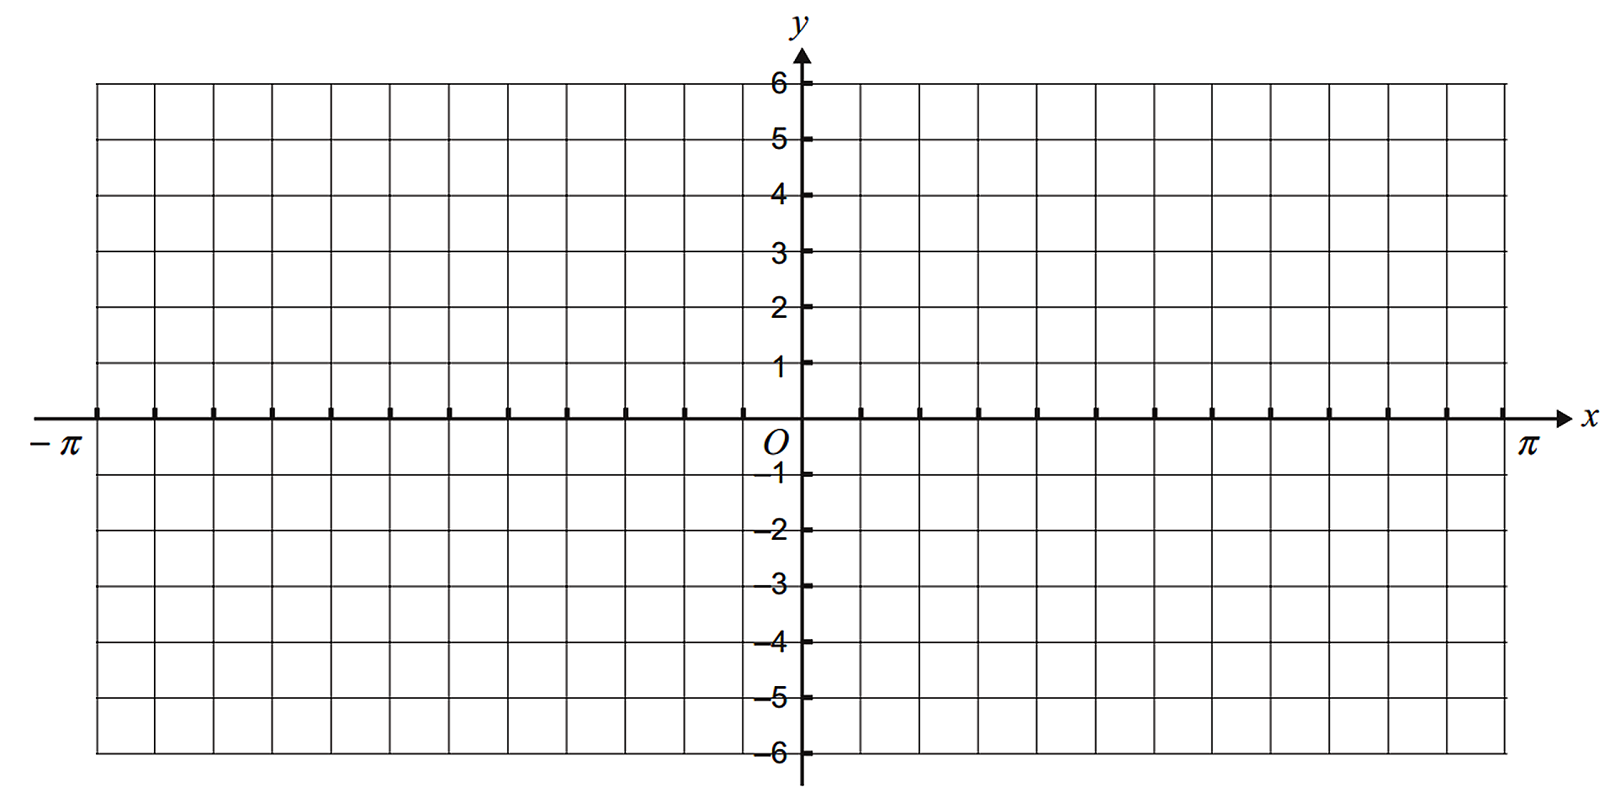
  - Sketch $f\left(x\right)$ on the set of axes below, labelling axes intercepts and endpoints.

- HSC Advanced Sample Question Band 5
By drawing graphs on the number plane, show how many solutions exist for the equation
$\cos{x}=\left|\frac{x-π}{4}\right|$ in the domain $\left(-∞,∞\right)$.
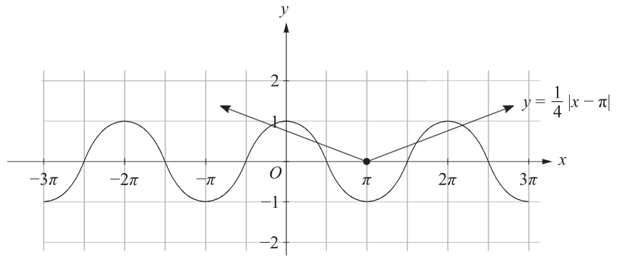
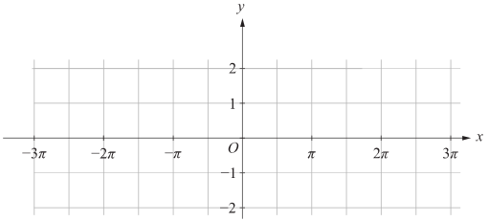

4 points of intersection, so 4 solutions

- HSC Advanced Sample Question Band 5
$f\left(x\right)=2\sin\left(2x\right)$ is defined in the domain $\left\{x:\frac{π}{8}≤x≤\frac{π}{3}\right\}$.
What is the range of this function?

Maximum occurs when $\sin\left(2x\right)=1$
$$2x=\frac{π}{2}$$
$$x=\frac{π}{4}$$
Therefore, maximum value of $2$ is in the domain.
Check endpoints: $y\left(\frac{π}{8}\right)=\sqrt{2}$
$$y\left(\frac{π}{3}\right)=\sqrt{3}$$
So, the minimum value is $\sqrt{2}$
$$∴\left[\sqrt{2},2\right]$$

